CAD Capstone Project 2024

Indie Fusion

Team #1 - Transition Phase

Client Name: Dream Wave Productions

Team name : Indie Synergy

Team Members :

Sruthi Kamishetti

Twinkle Mishra

Naina Jagiasi

**Course Code: INFO8106-24F**

**Instructor: Regan Benner**

**Due Date: Nov 2nd, 2024**

# Table of Contents

Table of Contents 2

Quick Start Guide 3

Quick Start Guide for Creating Your Indie Fusion Account 3

Forgot Password Guide 5

Reset Password Guide 6

Updating Your Profile for the First Time 7

Home Page Guide 8

Guide for Creating a Post 9

Guide for Groups 12

Guide for Events 16

Guide for My Collaborations 17

Guide for Notifications 20

Guide for Search 21

Guide for Profile Page 23

Guide for Logout 24

FAQs 25

Troubleshooting Guide 26

Future Enhancements for Indie Fusion………………………………………………………. 28

UAT Plan for Website……………………………………………………………………………...29

Test Cases 29

UAT Results 32

Deployment Guide 47

Working Code Demonstration 52

# Quick Start Guide

### Quick Start Guide for Creating Your Indie Fusion Account

* Open the **Indie Fusion** app.
* On the home screen, tap on **“Login/Register.”**
* Once on the login page, find the **Register** option at the top-right or the bottom of the login form.
* Click on **Register** to proceed to the registration page.
* Fill in all the required fields accurately.
* Ensure to use a valid and unique email address, as you cannot create multiple accounts with the same email.
* Finally, click the **Register** button at the bottom of the form to complete your registration.

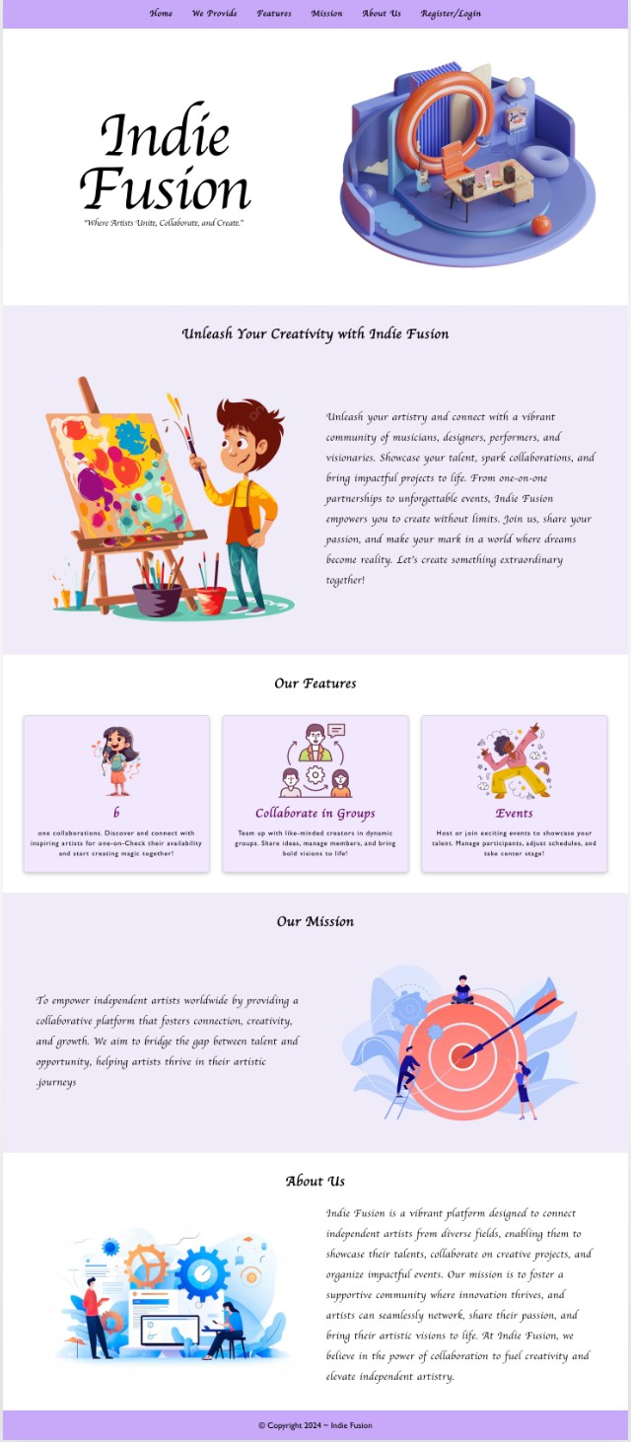 Figure 1:

Figure 2:

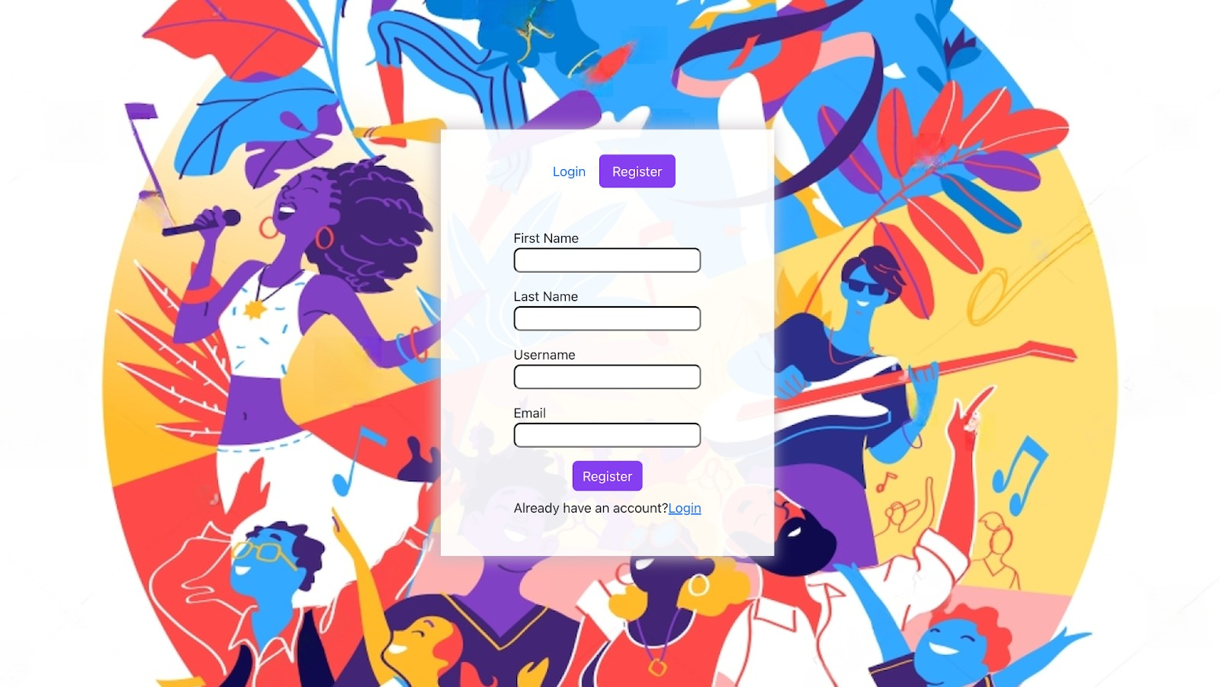

**How to Log into Your Indie Fusion Account**

* Open the **Indie Fusion** app or visit the Indie Fusion website.
* On the home screen, tap or click on **“Login/Register.”**
* On the login page, locate the fields for **Email Address** and **Password.**
* Enter the **email address** you used to register your account and the **password** that was sent to your registered email after completing the signup process.
  + Tip: Check your email inbox or spam folder for the email containing your login credentials.
* Once all details are correctly entered, click the **Login** button to access your account.

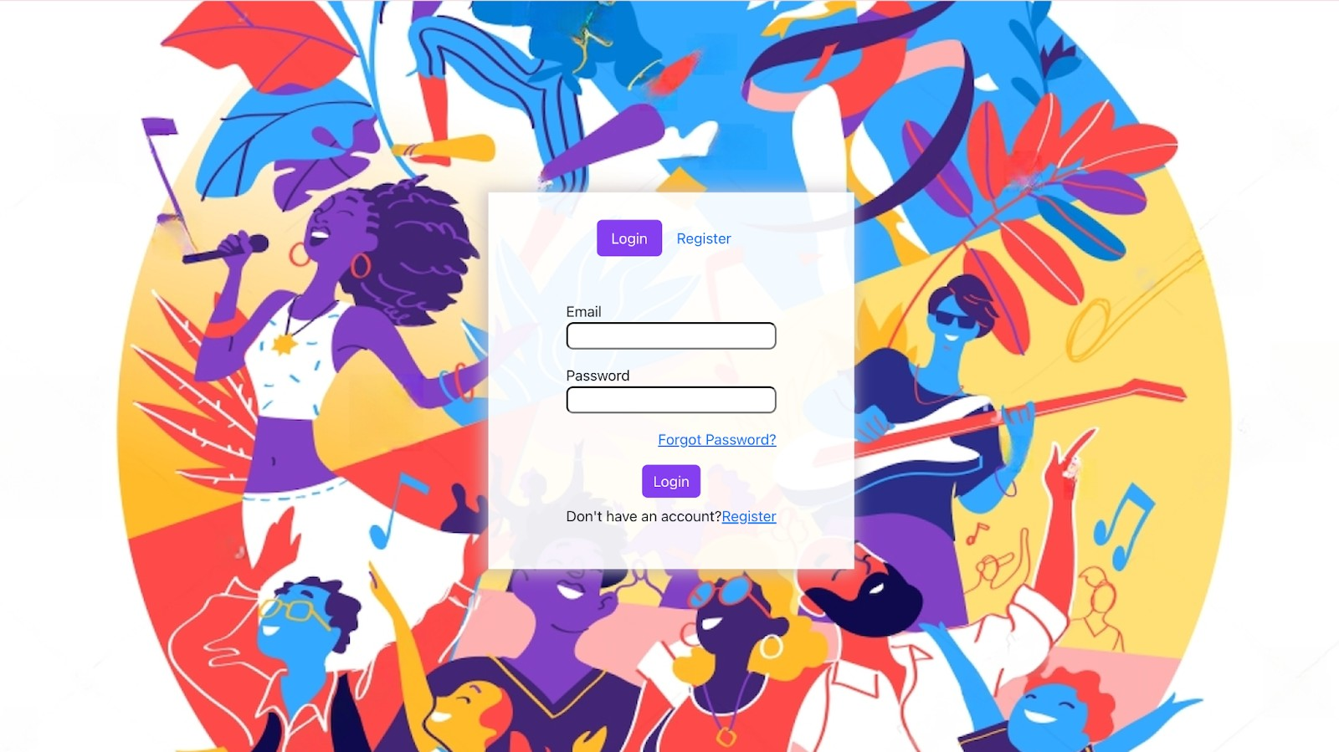Figure 3:

### Forgot Password Guide

### If you forget your password, follow these simple steps to reset it

### and regain access to your account:

#### Access the Forgot Password Page

* + On the **Login** screen, click the **Forgot Password?** link located below the password field.

#### Enter Your Registered Email

* + Enter the email address you used during registration in the provided field.
  + Ensure that the email address is correct; otherwise, you will not receive the new password.

#### Submit Your Request

* + Click the **Submit** button to send a password reset request.
  + A confirmation message will appear on the screen, indicating that a new password has been sent to your registered email address.

#### Check Your Email

* + Open your email inbox and locate the email from **Indie Fusion** containing your new password.
  + If you don’t see the email in your inbox, check your spam or junk folder.

#### Log In with Your New Password

* + Return to the **Login** page and enter your registered email address along with the new password sent to you.
  + Click **Login** to access your account.

#### Change Your Password (Optional)

* + Once logged in, it is recommended to change the new system-generated password to one of your choices for better security.
  + Navigate to **Reset Password** and update your password.

Figure 4:

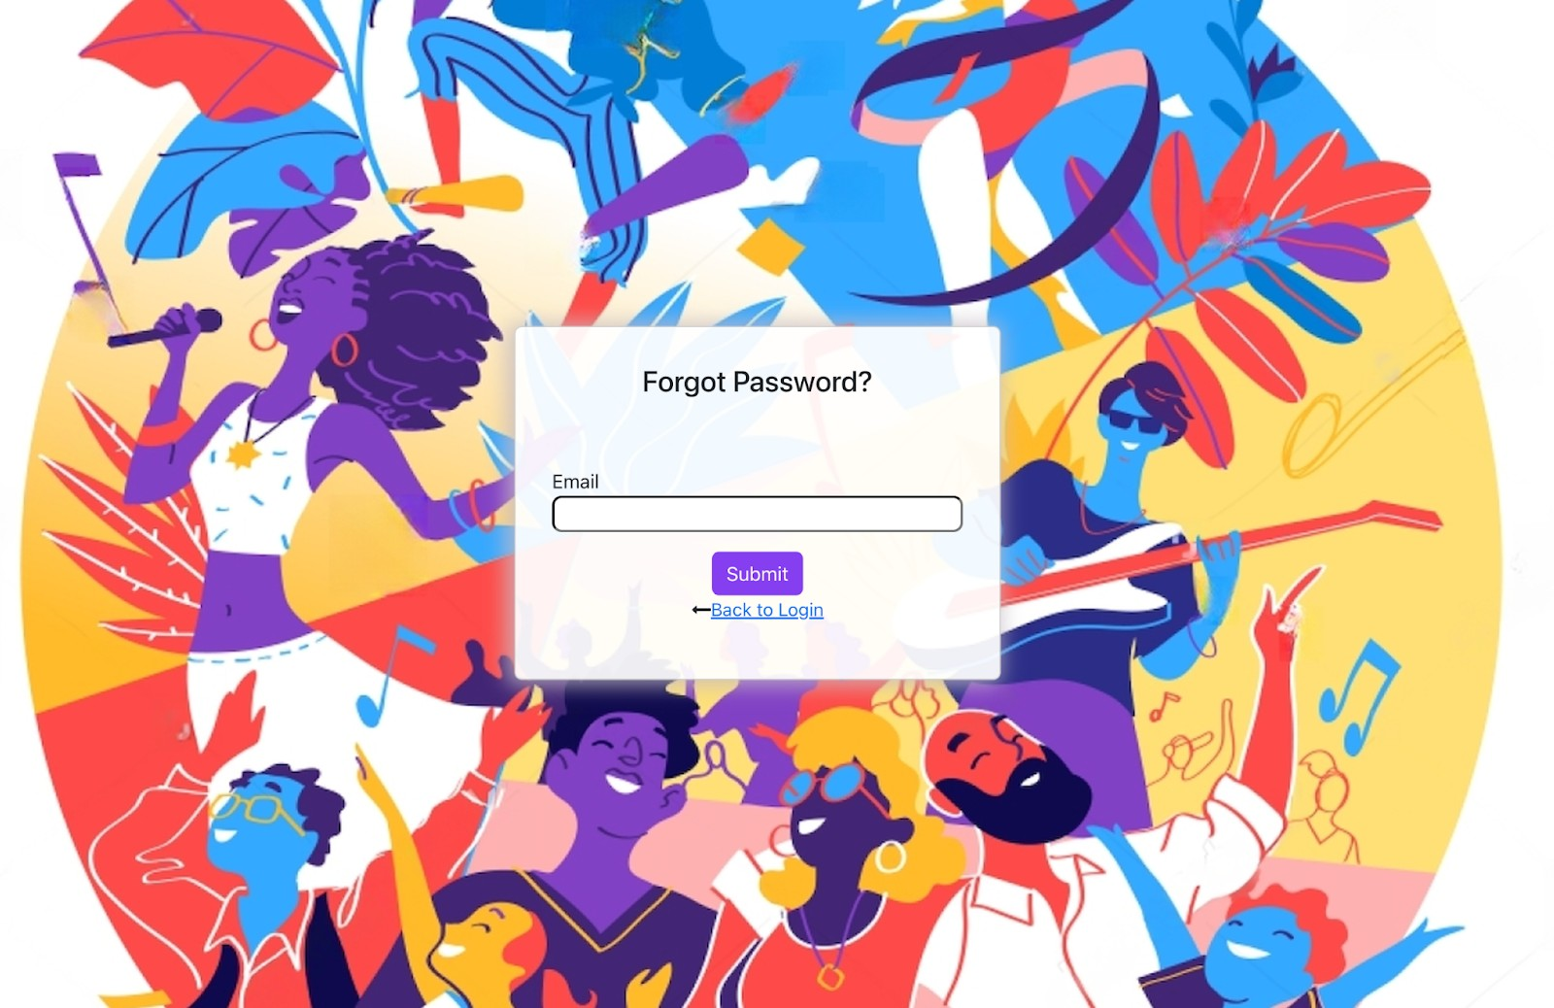

### Reset Password Guide

If you need to reset your password, follow the steps outlined below:

#### Access Reset Password Page

* After logging into your account, locate **Reset Password** in the **Side Navigation**

menu.

* Click on **Reset Password** to navigate to the reset password page.

#### Enter Your Current Password

* The first time you are resetting your password, you will need to enter the **old password** that was sent to your email when you registered.
* Ensure that you enter the correct old password as provided to you.

#### Enter Your New Password

* In the **New Password** field, enter a strong password of your choice.
* Make sure the new password is different from the old one for security reasons.

#### Confirm Your New Password

* In the **Confirm Password** field, re-enter the new password to confirm it.
* This ensures that there are no mistakes in your new password.

#### Click Reset Password

* Once both the new password and confirmation password fields are filled out correctly, click on the **Reset Password** button to update your password.

#### Log In with New Password

* After successfully resetting your password, you can log in using your **email address**

and the newly set password.

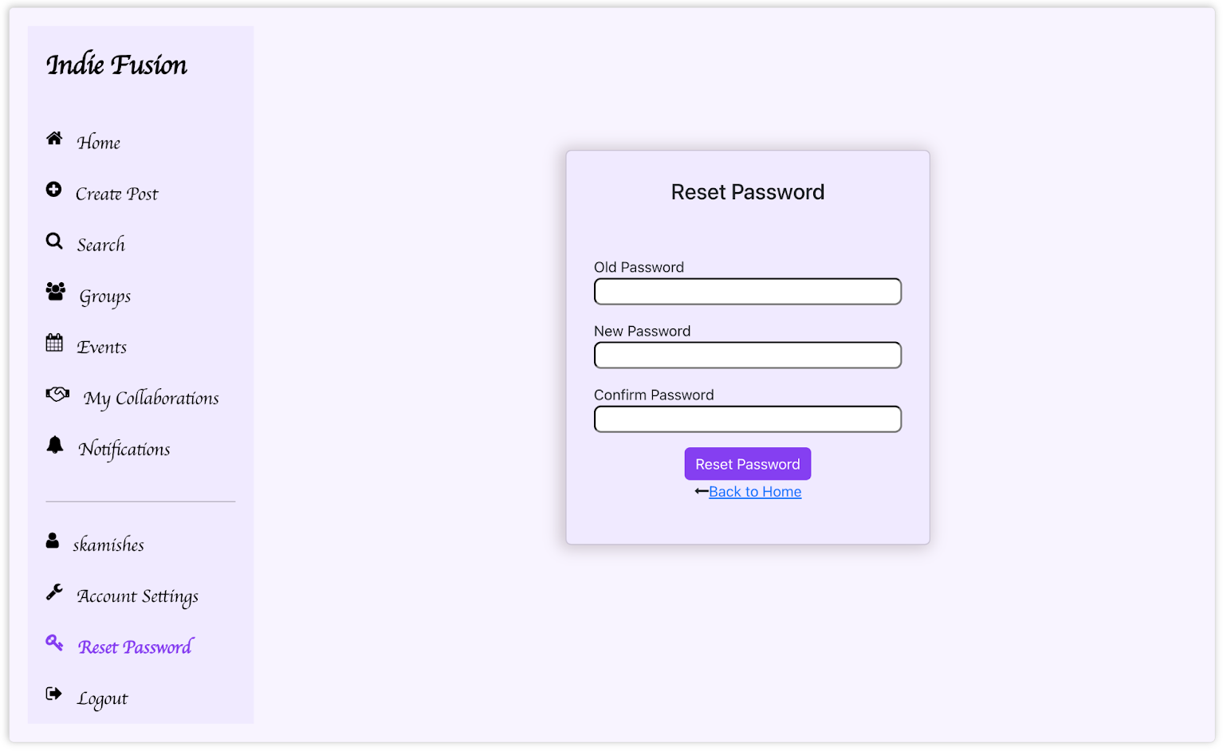Figure 5:

### Updating Your Profile for the First Time

### After logging in for the first time, users must update their profile to

### complete their account setup. Most of the details will already be pre-filled

### from the registration process. Follow the steps below to ensure all

### necessary information is provided, and the account is active for collaboration:

#### Accessing Profile Settings

* + Click on the **Account Settings** option in the left navigation menu.

#### Profile Information

* + **Username and Email**: Your username and registered email address will already be displayed at the top. These cannot be changed.

#### Open to Collab:

* + - Toggle this option to **ON** if you want to indicate that you are open to collaboration opportunities.
    - **Note**: If this setting is **ON**, other users can send collaboration requests to you. If it is **OFF**, no collaboration requests will be allowed.

#### Active:

* + - Toggle this option to **ON** to keep your account active and visible to others.

#### Personal Details

* + **First Name and Last Name**: Ensure your first and last name are accurate. You can update them if needed.
  + **Phone Number**: Verify or update your contact number for easy communication.
  + **Address**: Enter your full address, including street name and house number.

#### Location Details

* + **Country and City**: Select your country and city from the dropdown lists to specify your location.

#### Demographics

* + **Gender**: Select your gender from the available options.
  + **Date of Birth (DOB)**: Enter your date of birth in the format YYYY-MM-DD.

#### Skills and Interests

* + **Skills**: Specify your primary skills (e.g., Singing, Dancing, Musician, etc.). These indicate what you can contribute to collaborations.
  + **Interests**: Mention your interests (e.g., Singing, Dancing, Musician, etc.) to show areas where you'd like to engage.

#### Bio

* + Provide a short description about yourself in the **Bio** section. This is an optional field but helps others know more about you.

#### Save Changes

* + Once all fields are reviewed and filled, click the **Update** button at the top-right corner of the form to save your profile settings.

Figure 6:

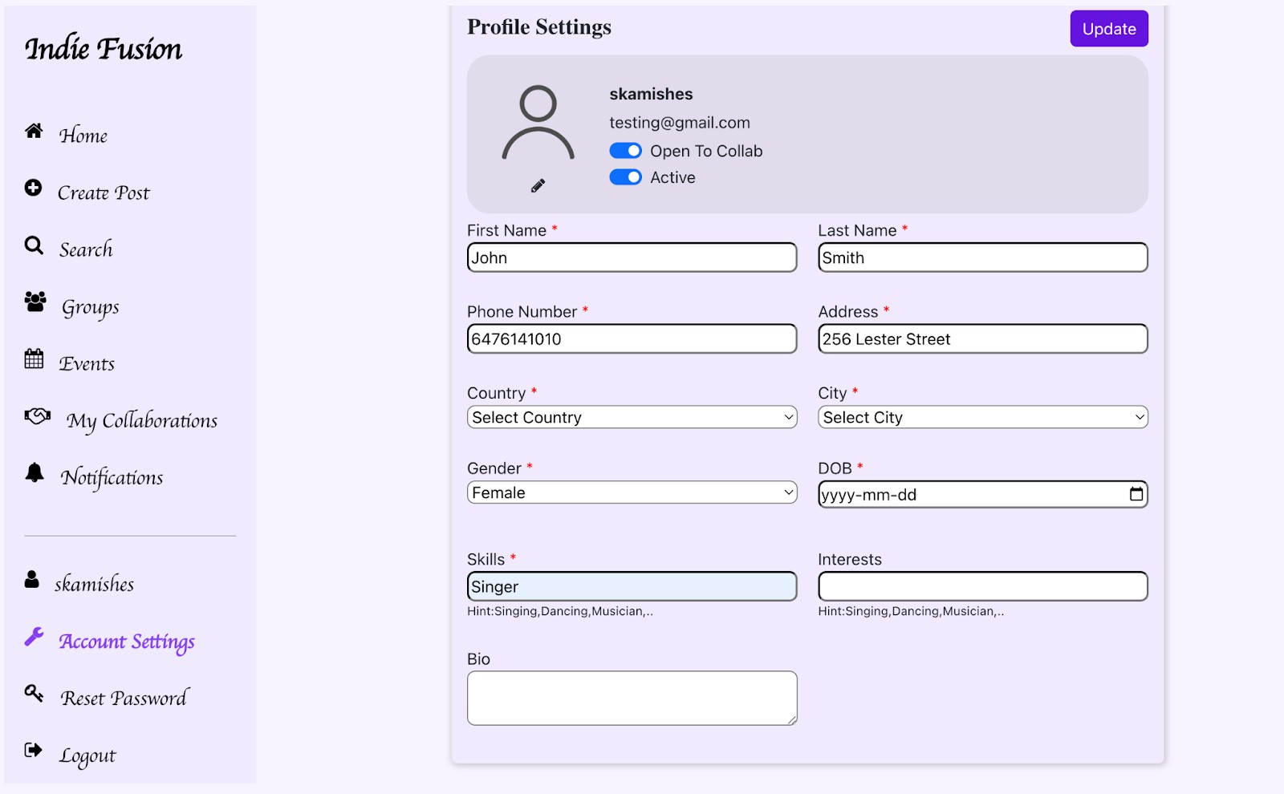

### Home Page Guide

The **Home Page** is where users can interact with various content such as individual posts, group posts, and events. Here's a detailed guide on how to navigate and use the Home Page:

#### View Posts

* The Home Page displays all posts related to **individual posts**, **group posts**, and

#### events.

* **Individual Posts**: View posts made by other users and yourself.
* **Group Posts**: See group posts shared by others.

#### Join Groups

* If you're interested in a group, you can **send a request to join the group** directly from the Home Page.
* The request will be sent to the group admin for approval.

#### Event Details

* The Home Page also displays **events** that are created by individual users.
* You can explore event details and get involved in the events.

#### Sharing Links

* **Authenticated users** can share the links to posts, groups, and events.
* Only users who are **logged in** can access these links and interact with the content.

#### Manage Own Posts

* If the post displayed is your own, you will have the option to **edit** or **delete** the post.
* This can be done by selecting the corresponding **edit** or **delete** options available with your post.

#### Navigate Using Side Navigation Bar

* The **Side Navigation Bar** allows easy navigation to other sections of the platform such as:
  + Home
  + Create Post
  + Search
  + Groups
  + Events
  + My Collaborations
  + Notifications
  + Account Settings
  + Reset Password
  + Logout
* You can access any of these sections directly through the side navigation bar without needing to go back to the Home Page.

Figure 7:

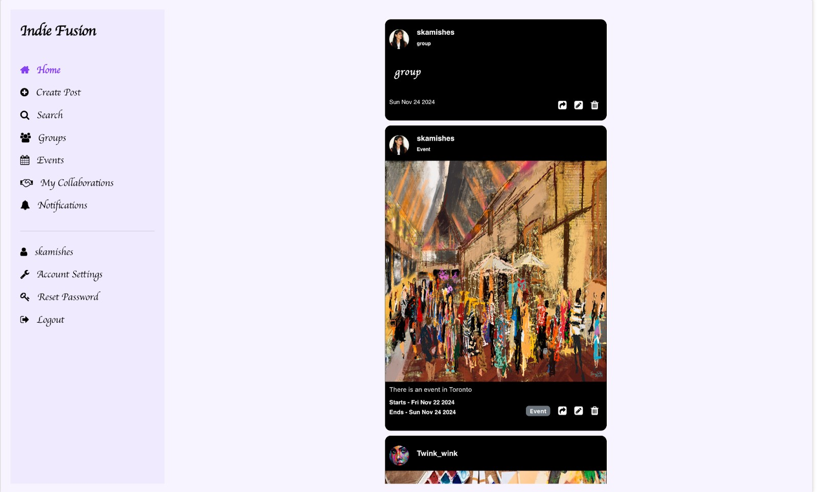

### Guide for Creating a Post

There are **three distinct types** of posts you can create on the platform, each designed for different purposes. Below is a detailed guide on how to create each type of post:

#### Self-Post

* + A **Self Post** allows artists to showcase their individual talents.
  + This type of post can include **images**, **videos**, or **performances** that highlight your work and creativity.
  + **Self-Post** is intended for personal promotion and is visible to others who can view your profile and posts.

#### Steps to Create a Self-Post:

1. Navigate to the **Create Post** section.
2. Select **Self Post** as the post type.
3. Add a brief description or additional context for the post in **status**.
4. Upload the relevant content (images, videos, etc.).
5. Click **Create** to create the self-post.

Figure 8:

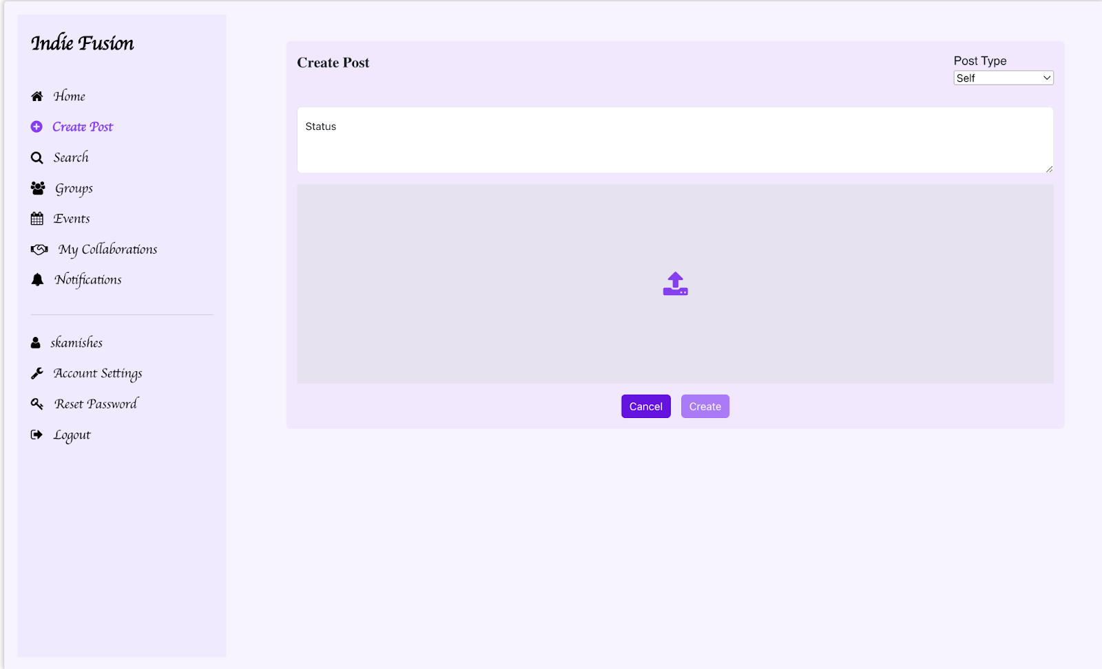

#### Collab Post

A **Collab Post** allows users to collaborate with others by creating or joining groups.

* + When a Collab Post is created, the creator automatically becomes the **group admin**.
  + Other users can request to join the group, and the group admin is responsible for

#### accepting or rejecting requests.

* + The Collab Post provides an effective way to connect with others and facilitate collaborative opportunities within the platform.

#### Steps to Create a Collab Post:

* + Navigate to the **Create Post** section.
  + Select **Collab Post** as the post type.
  + Provide **the title** of the post.
  + Provide a **detailed description** of the collaboration opportunity in the **Status**.
  + Click **Post** to create and publish the Collab Post.

#### How Users Join the Group:

* + Other users can view the Collab Post and send a **request to join the group**.
  + The creator of the Collab Post (group admin) will review each request and either

#### approve or reject it.

* + Once approved, the user becomes a member of the group and gains access to interact with other members.

Figure 9:

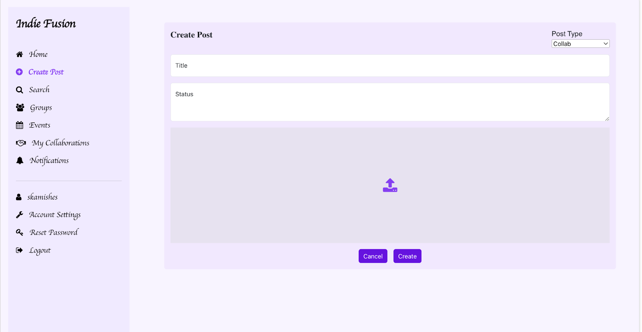

#### Event Post

* + The **Event Post** allows users to create an event post.
  + This post type includes the event’s **title**, **description**, **start and end dates**.
  + Event posts are intended for broad visibility, allowing anyone on the platform to view the event details and participate.

#### Steps to Create an Event Post:

1. Navigate to the **Create Post** section.
2. Select **Event Post** as the post type.
3. Enter the **event title**, **description**, and any additional event details.
4. Specify the **start date** and **end date** for the event.
5. Click **Post** to share your event with the platform's users.

Figure 10:

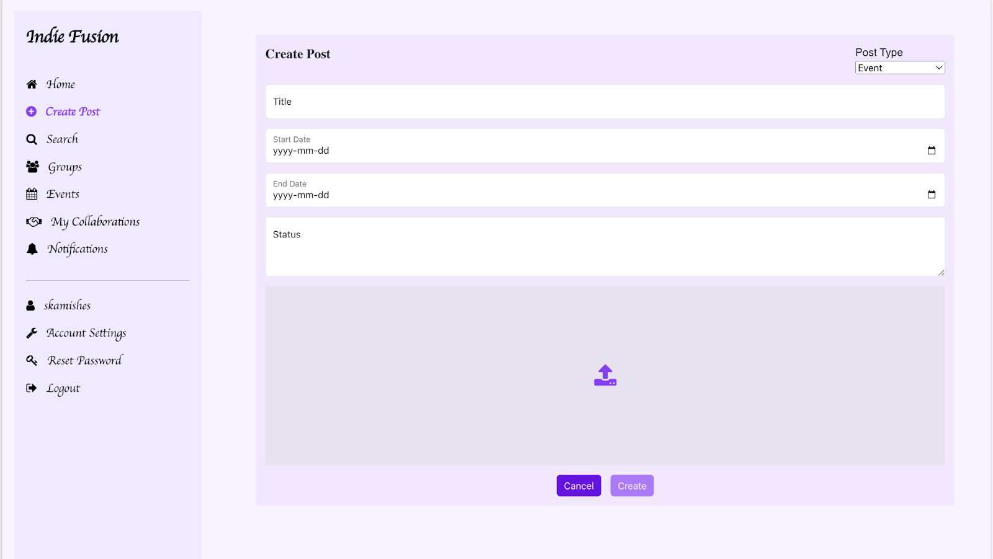

### Guide for Groups

Groups provide a collaborative space where users can create, join, and manage their groups. In the **Groups** section, you can view all groups, including the ones you have created, those you have requested to join, and those you have been accepted into. By clicking on a specific group, you can access more detailed information about it.

#### Group Details Overview:

* + **Groups**: All the groups you have created, requested to join, or have been accepted into will be displayed here.

Figure 11:

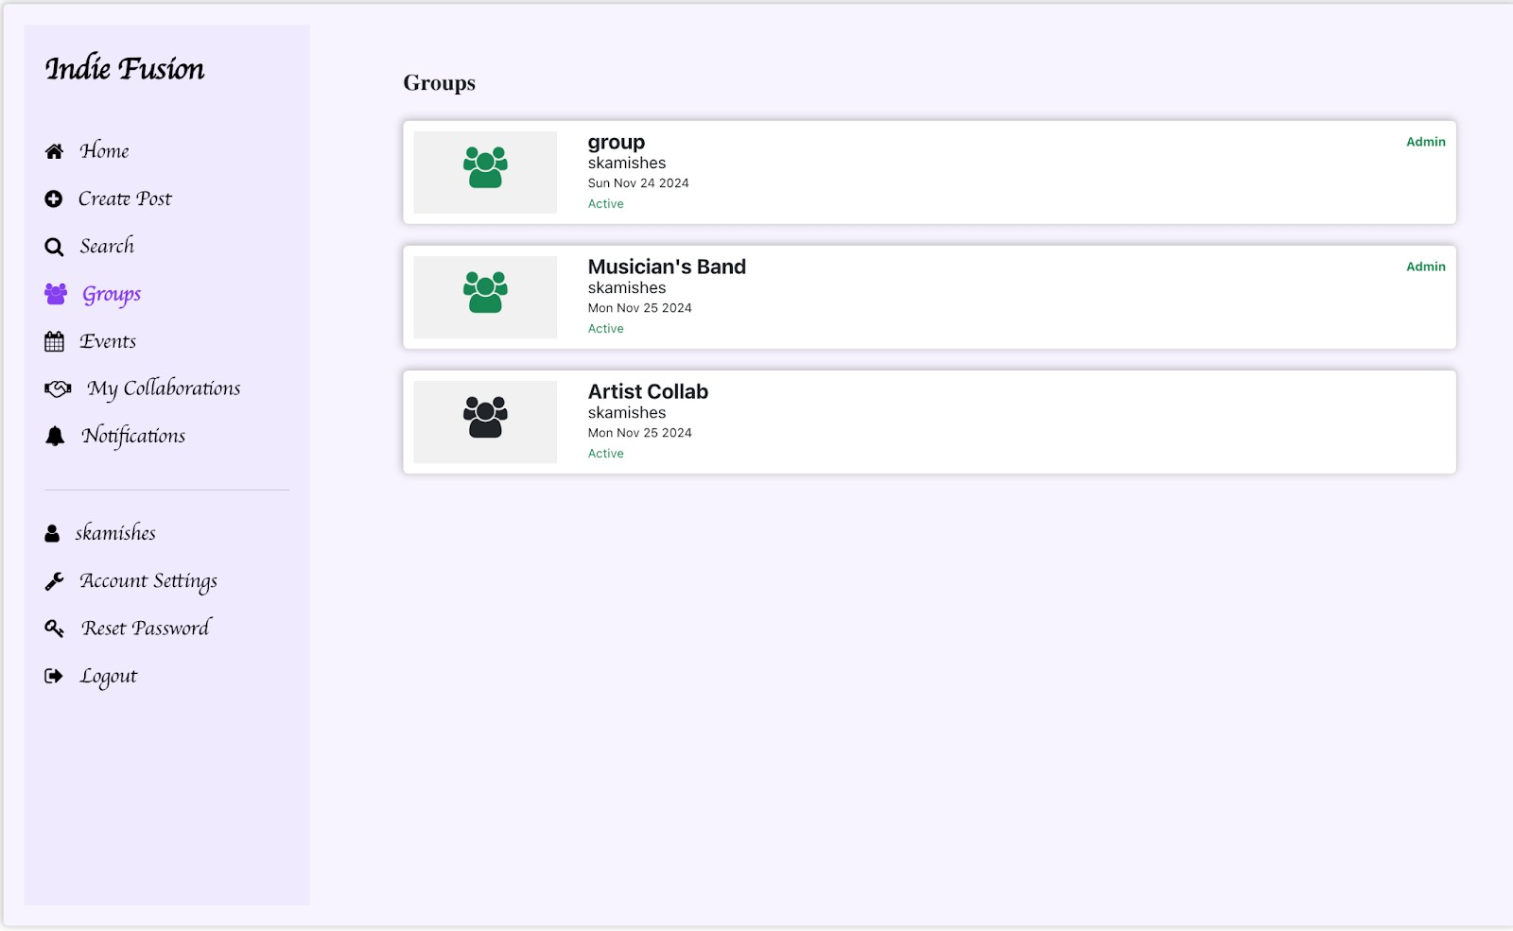

* + **Group Info**: Clicking on a specific group will provide detailed information about the group, including its members, activities, and admin controls.

Figure 12:

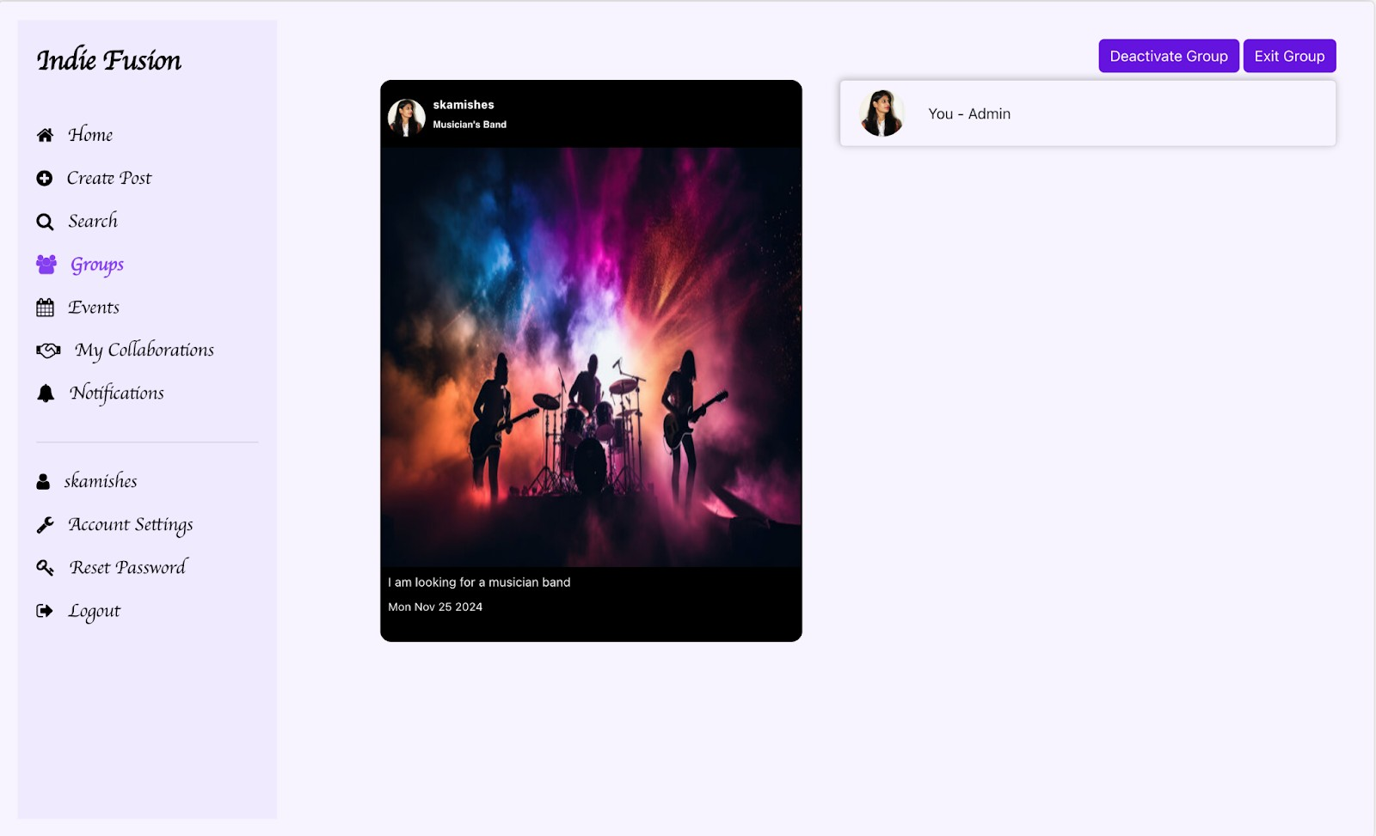

**As an Admin of the Group:**

If you are the **admin** of a group, you will have access to manage various settings and requests within the group:

#### Manage Membership Requests

* + You can see all incoming **membership requests**.
  + As an admin, you have the authority to **accept** or **reject** these requests.

#### Activate/Deactivate Group

* + You have the option to **deactivate** the group if you wish to temporarily stop its activity. This allows the group to be reused later without losing any data.
  + If you decide the group is no longer needed, you can **permanently delete** it by **exiting the group**.

#### Exiting the Group

* + If you wish to exit the group, the group will be **deleted** upon confirmation. Please note that once deleted, the group cannot be recovered.

#### Re-accept or Reject Members

* + After accepting a member into the group, you can **reject** them if needed.
  + You also have the ability to **re-accept** a member who was previously rejected.

Figure 13:

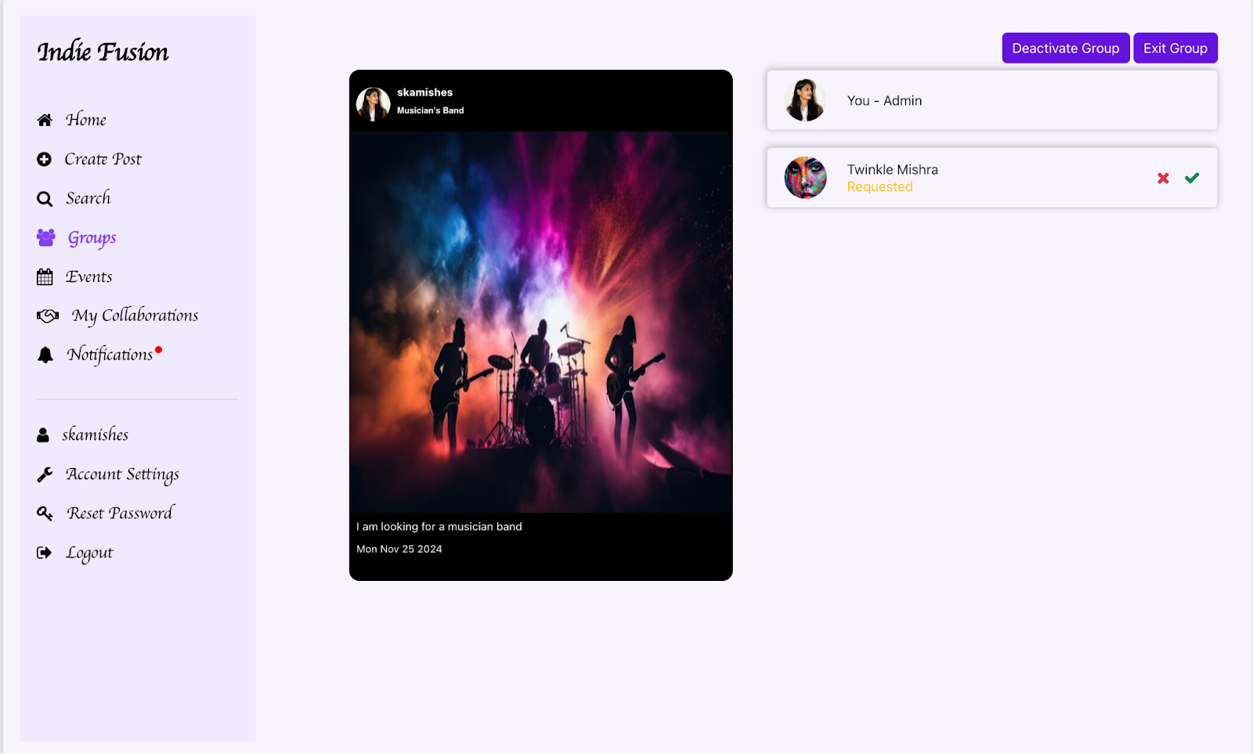

**As a Member of the Group:**

As a **member** of a group, you will have the following permissions:

#### View Accepted Members

* + You can see the list of **group members** who have been accepted by the admin.

#### Exit the Group

* + If needed, you can choose to **exit the group** at any time. Upon exiting, you will no longer be able to access the group’s activities or details.

Figure 14:

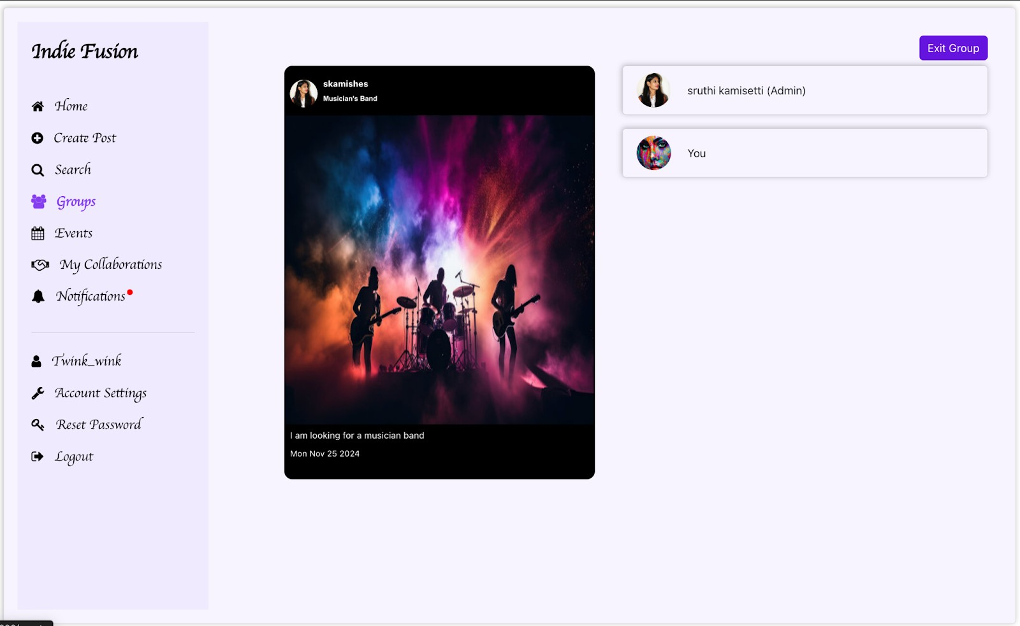

* + If you wish to **rejoin the group**, you must send a new **membership request**. Until the admin **accepts or rejects** your request, your status will remain as **Requested**, and you will not be able to view or perform any actions in the group.

Figure 15:

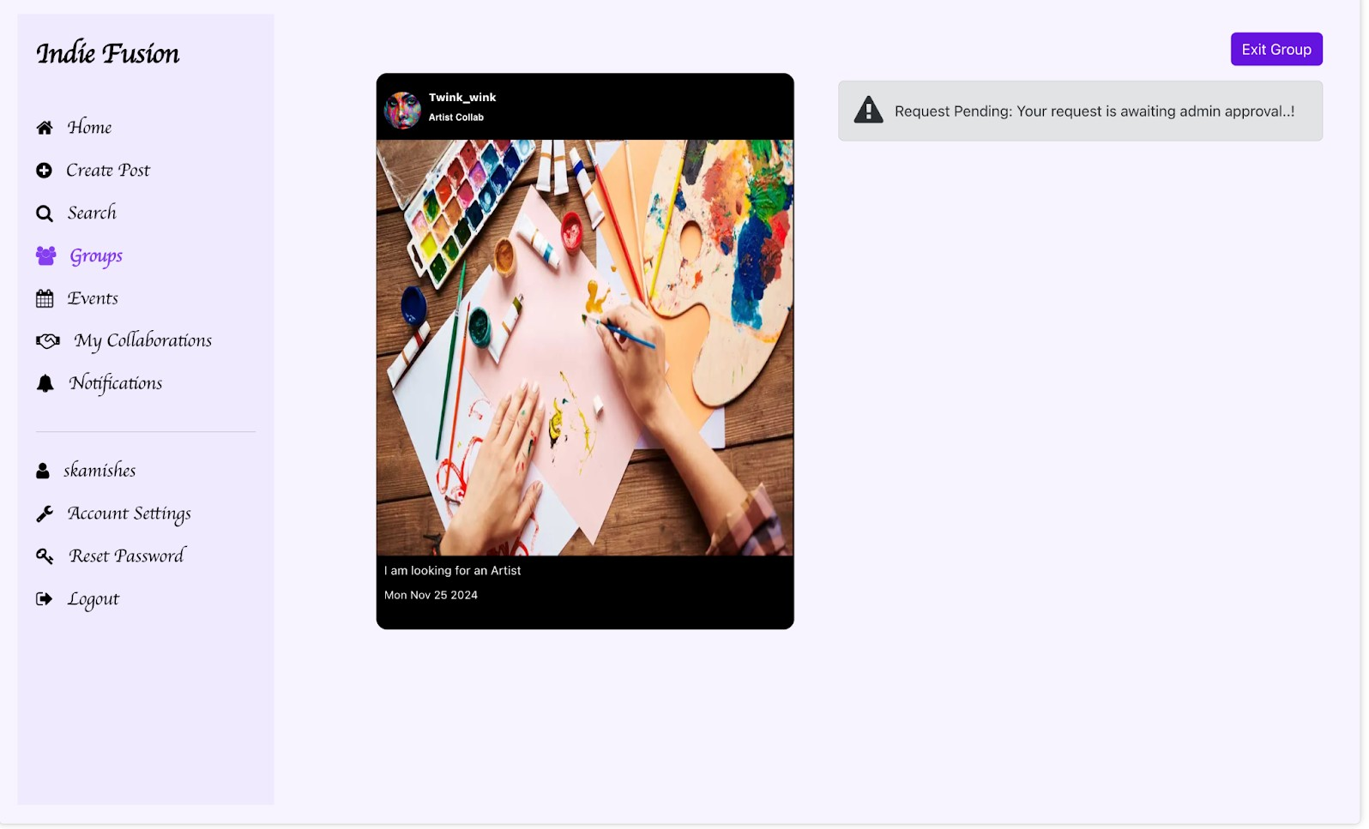

### Guide for Events

The **Events** section allows users to explore, create, and manage events within the platform. Events can be created by any user and provide an opportunity to share important details about performances, gatherings, or collaborations.

#### Overview of Events Section:

* + The **Events** section displays a list of all events, including those created by you and those created by other users.
  + Each event is displayed with its title and brief information to help you identify it quickly.

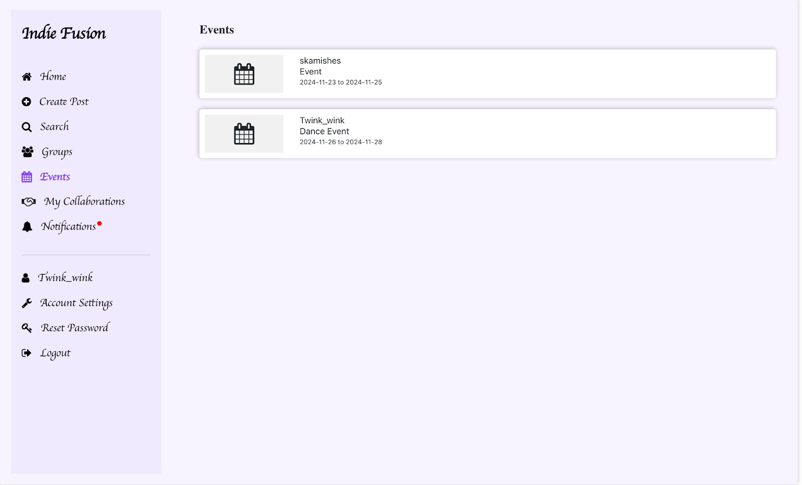Figure 16:

#### Viewing Event Details:

* + Click on a specific event to view its complete details, including:
    - **Event Title**: The name of the event.
    - **Description**: A detailed explanation of the event.
    - **Start and End Dates**: The scheduled duration of the event.

Figure 17:

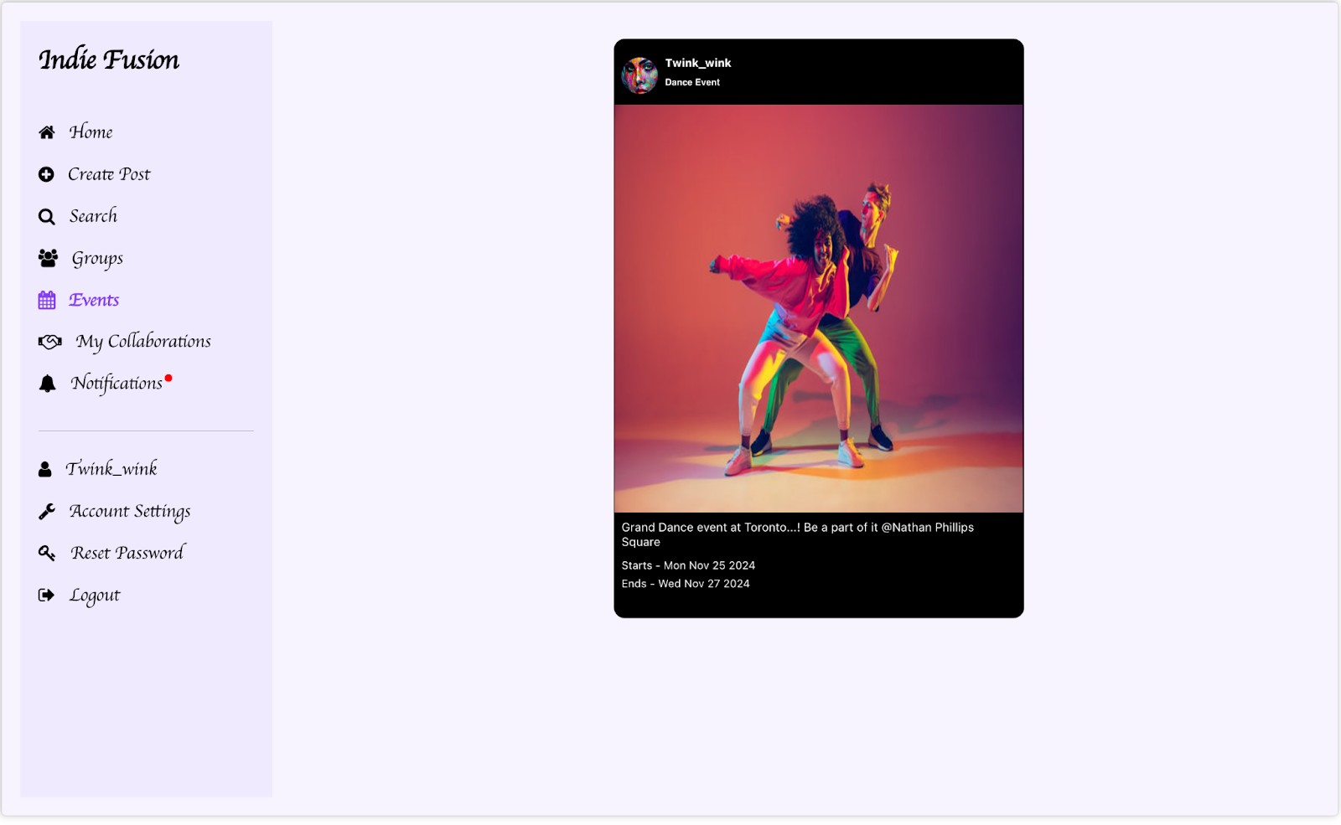

### Guide for My Collaborations

The **My Collaborations** section provides an organized list of:

* + Individuals you are currently collaborating with.
  + Requests from others who wish to collaborate with you.

#### Sending a Collaboration Request:

1. When you find a **Self Post** that interests you, click on the profile of the individual who created the post.
2. Review the **profile details** and explore their other posts to learn more about their work.

Figure 18:

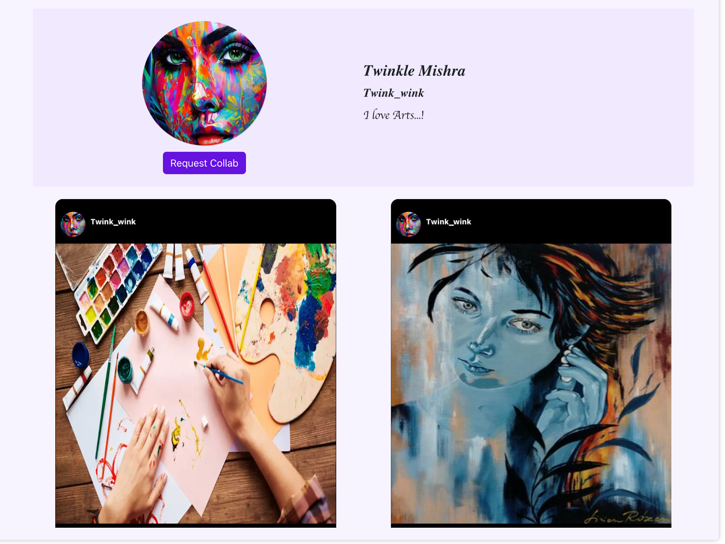

1. If you wish to collaborate, send a **Collaboration Request** along with a personalized message explaining your interest.

Figure 19:

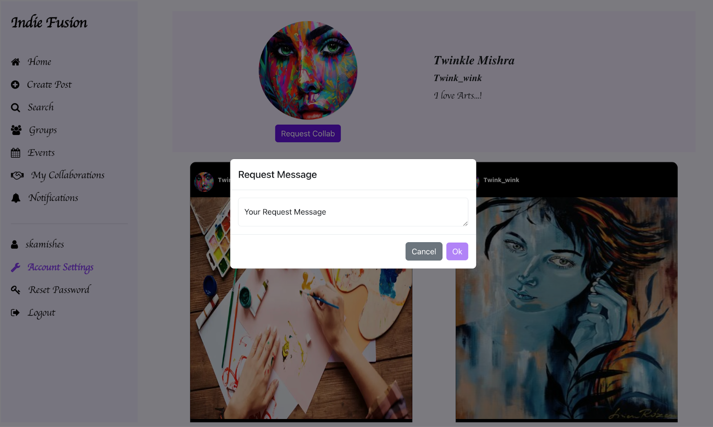

#### Notification for Collaboration Requests:

* + Once you send a collaboration request, the recipient will receive a **notification**

containing:

* + - Your **request** to collaborate.
    - The **message** you sent along with the request.

Figure 20:

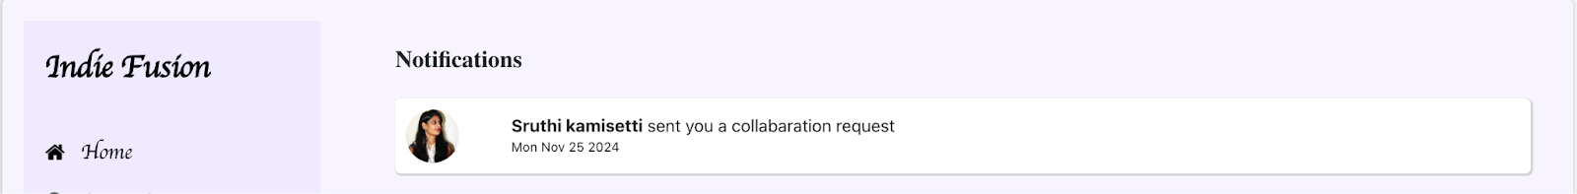

Figure 21:

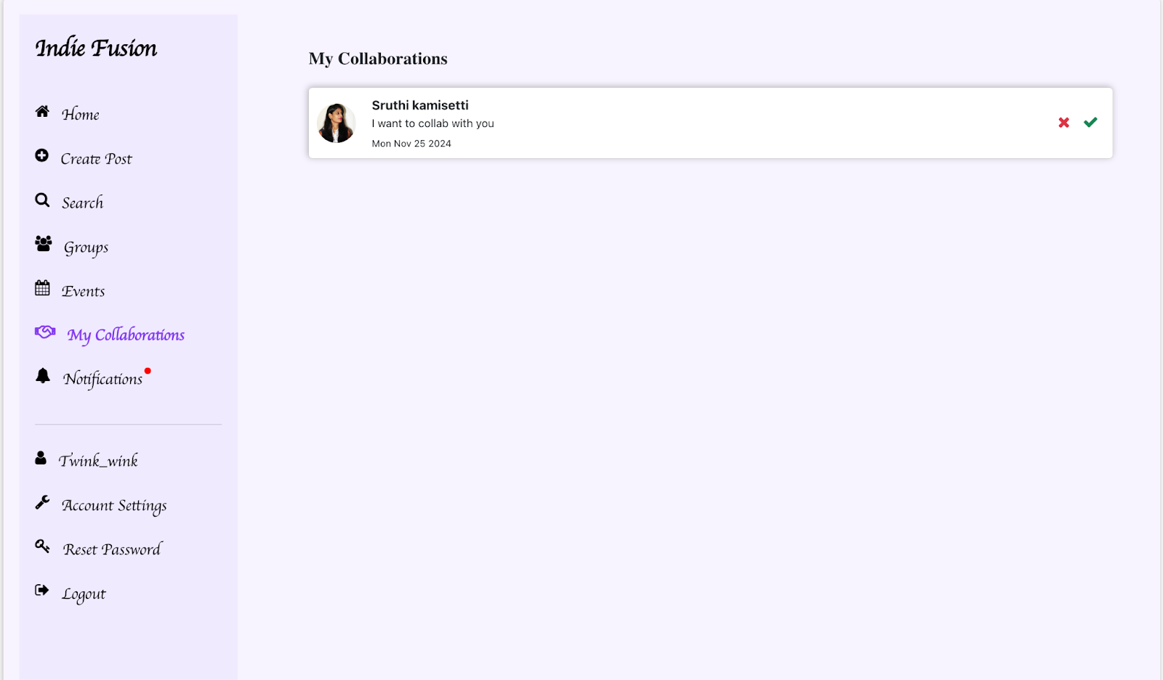

#### Reviewing and Managing Collaboration Requests:

* + The recipient can view your complete profile and all your posts to evaluate your suitability for collaboration.
  + Based on their assessment, they can choose to:
    - **Accept** the collaboration request, initiating the collaboration.
    - **Reject** the collaboration request if it doesn’t align with their preferences.

Figure 22:

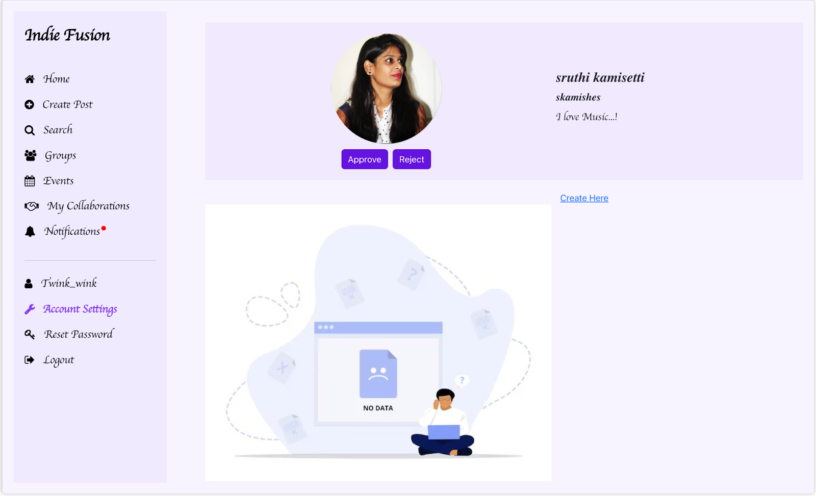

Once a collaboration request is accepted or rejected, a **notification** will be sent to the sender, informing them of the decision.

Figure 23:

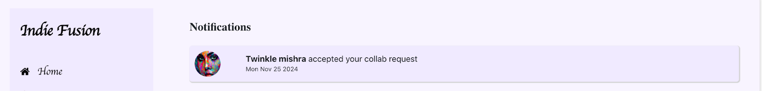

* + If the request is **accepted**, the collaboration status will be updated to **"Collabed"** on the profile of the person who sent the request.

Figure 24:

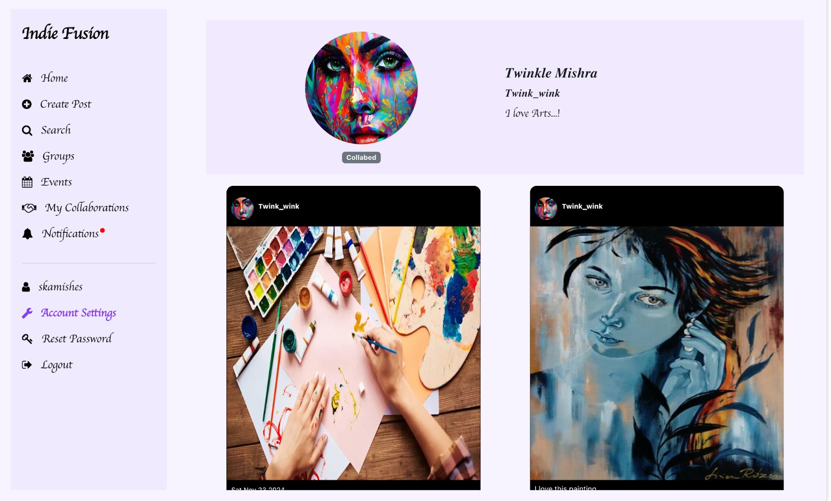

* + If the request is **rejected**, the person who sent the request will have the option to

**send a new request** at any time.

### Guide for Notifications

The **Notifications** section keeps you updated on important activities and interactions within the platform, ensuring that you never miss an important update.

#### Types of Notifications:

#### Collaboration Requests:

* + Receive notifications when someone sends a collaboration request to you, including the message they provided with the request.
  + Notifications are also sent when your request to collaborate is either accepted or rejected.
  + When a **collaboration request notification** is selected, you will be taken directly to the profile of the person who sent the request.

#### Group Requests:

* + Get notified when someone requests to join a group you manage or belong to.
  + Admins will be alerted when new requests are made to join their groups.
  + When a **group notification** is clicked, it will redirect you to the specific group associated with the notification.

Figure 25:

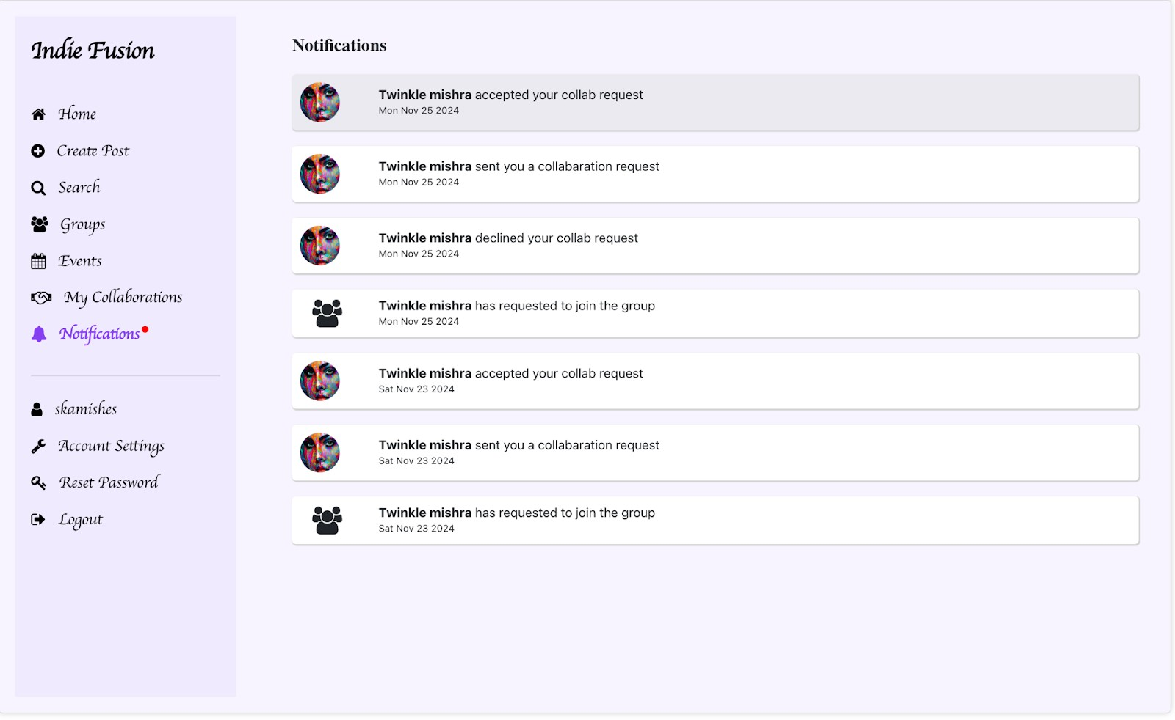

### Guide for Search

The **Search** feature allows you to find artists based on various criteria, making it easier to discover and connect with relevant profiles.

Figure 26:

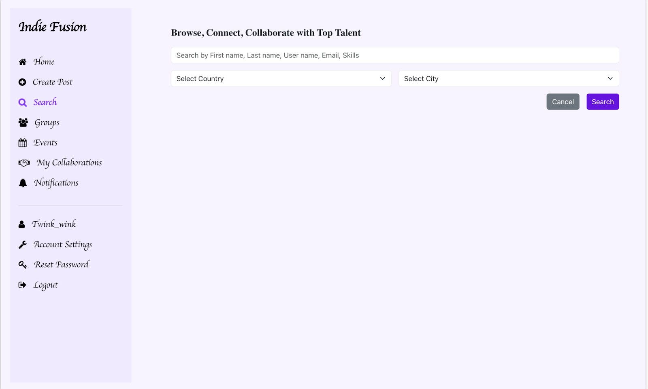

#### Search Criteria:

You can search for artists using the following parameters:

#### First Name

#### Last Name

#### Username

#### Email

#### Skills

#### City

#### Country Search Results:

* + The search will display a list of artists that match your search criteria.
  + If an artist is **not open to collaboration**, their profile will be shown, but it will be marked as **disabled**, indicating that they are currently unavailable for collaboration.

Figure 27:

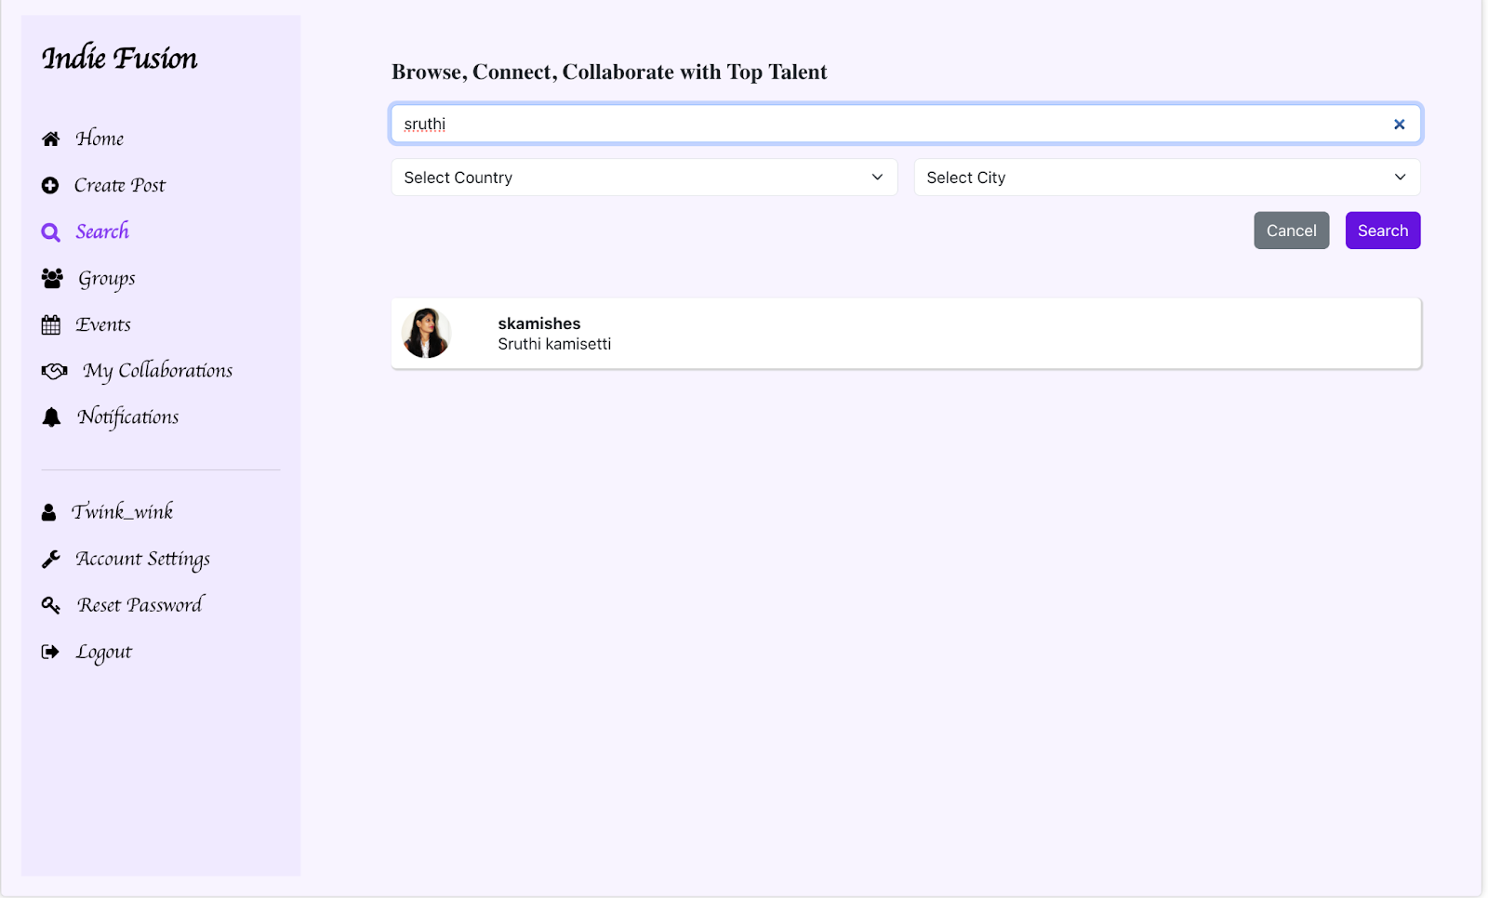

* + If no results match your search criteria, a message will be displayed indicating that **no data** was found, meaning there are no artists that meet the specified search parameters.

Figure 28:

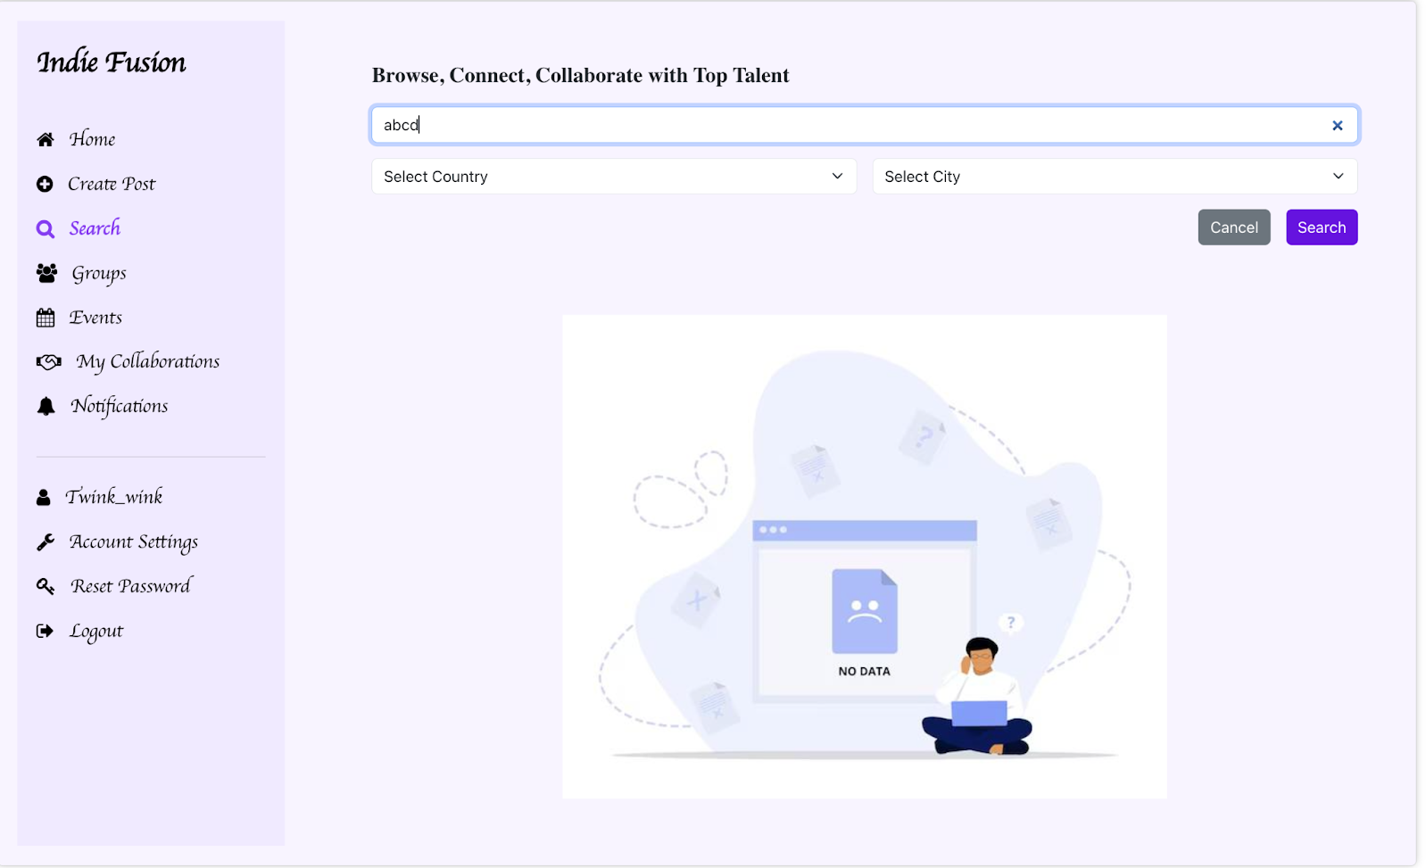

The **Search** feature provides a streamlined way to find and explore artists, ensuring you can connect with those who meet your needs and preferences.

### Guide for Profile Page

The **Profile Page** displays the details of an individual artist, providing an overview of their personal information and content.

#### Profile Details:

#### First Name

#### Last Name

#### Username

* + **Bio** – A brief description of the artist’s background or interests.
  + **Profile Image** – A visual representation of the artist.

#### Self Posts:

The Profile Page also showcases the **Self Posts** that the artist has created, allowing others to view their work and engage with it.

This page serves as a comprehensive snapshot of the artist, offering insight into their identity, content, and creative work.

Figure 29:

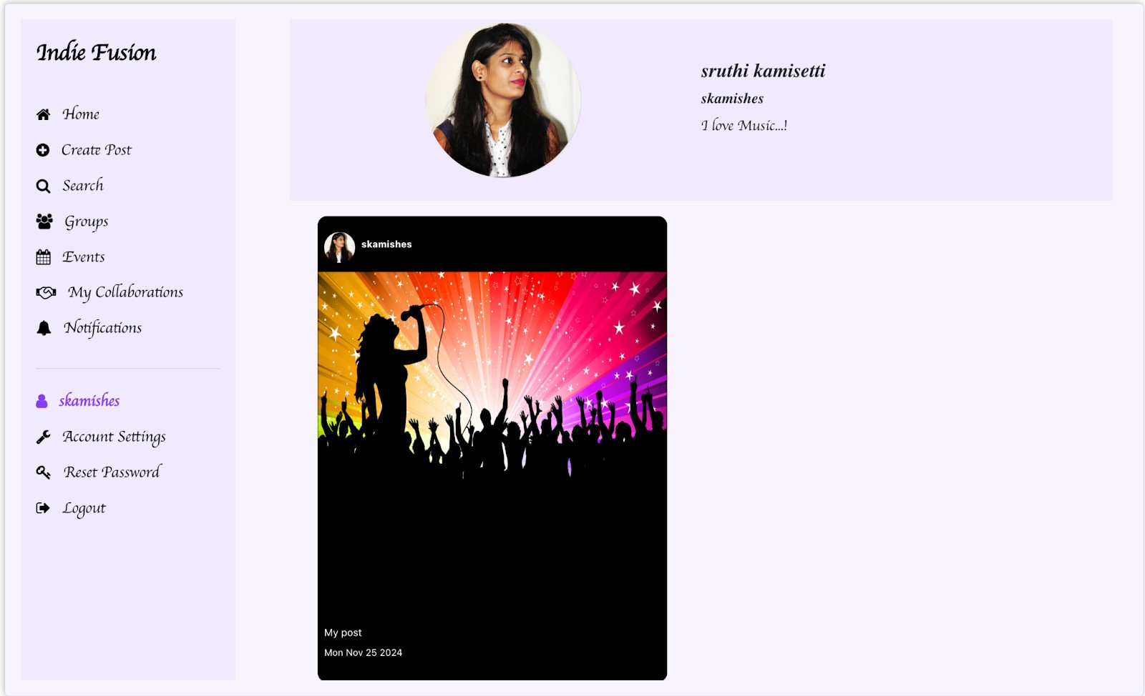

### Guide for Logout

Logging out of the platform ensures the security of your account and prevents unauthorized access. Here’s how to log out:

#### Steps to Logout:

1. Navigate to the **side navigation menu** or **account settings**.
2. Select the **Logout** option.
3. You will be logged out and redirected to the **Login page**.

After logging out, you will need to enter your credentials again to access your account. This helps protect your account from unauthorized access when using shared or public devices.

Figure 30:

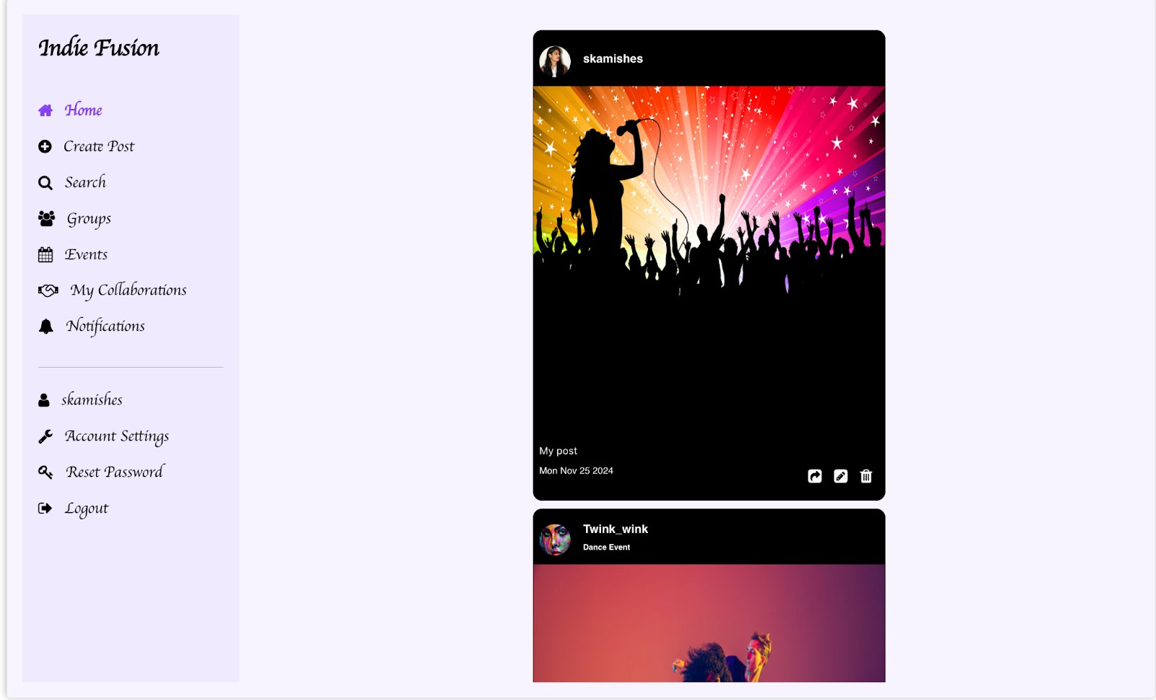

## FAQ’s

#### What happens if I register with the same email address multiple times?

* + **Q:** Can I register multiple accounts using the same email address?
  + **A:** No, the system does not allow multiple accounts with the same email address. If you attempt to register with an email that is already in use, you will receive an error message stating that the email is already registered. You can either log in with your existing account or use the **Forgot Password** option to reset your password if needed.

#### Can I delete a post I created?

* + **Q:** How do I remove a post I created?
  + **A:** Yes, if you created a post, you can edit or delete it from the respective section (Self Posts, Group Posts, or Events).

#### Can I leave a group I joined?

* + **Q:** Is it possible to exit a group I’m a member of?
  + **A:** Yes, you can leave a group at any time. If you wish to rejoin, you’ll need to send a new request, which the group admin must approve.

#### What happens if my group request is pending?

* + **Q:** Can I interact with a group if my request to join is still pending?
  + **A:** No, if your request is pending, you will not be able to see group details or perform any actions until the admin approves or rejects your request.

#### How do I manage my group as an admin?

* + **Q:** What actions can I perform as a group admin?
  + **A:** As an admin, you can:
    - View and manage membership requests.
    - Accept or reject requests.
    - Activate, deactivate, or delete the group.
    - Remove existing members from the group if necessary.

#### What is the difference between Self Posts, Group Posts, and Events?

* + **Q:** What types of posts can I create, and how are they different?

#### A:

* + - **Self-Post:** Showcase your individual talent through images, videos, or performances.
    - **Collab Post (Group Post):** Create a post to find collaborators or create a group for collaborative projects.
    - **Event:** Share event details such as title, description, and dates for others to view and join.

#### How do I search for other artists on the platform?

* + **Q:** What options are available for searching artists?
  + **A:** You can search for artists by entering criteria such as their first name, last name, username, email, skills, city, or country. Artists who are not open to collaboration will appear with their profiles disabled.

#### What is the purpose of the 'Open to Collab' toggle?

* + **Q:** What happens if I enable the 'Open to Collab' option?
  + **A:** Enabling 'Open to Collab' allows other users to send collaboration requests to you. If disabled, users will still see your profile but won’t be able to send collab requests.

**Troubleshooting Guide**

#### Unable to Register with My Email Address

* + **Issue:** You receive an error stating your email is already registered.

#### Solution:

* + - Ensure the email address you are using has not already been registered.
    - If it has, use the **Forgot Password** option to reset your password and regain access to your account.
    - Check for typos in the email address during registration.

#### Forgot Password Email Not Received

* + **Issue:** You did not receive an email after requesting a password reset.

#### Solution:

* + - Verify that the email address entered is correct and associated with your account.
    - Check your spam or junk email folder for the reset email.
    - If the issue persists, wait a few minutes and try again.
    - Contact support if the problem continues.

#### Unable to Log In After Registration

* + **Issue:** You can’t log in after completing the registration process.

#### Solution:

* + - Ensure you are using the correct email address and password.
    - Check the email sent during registration to confirm your login credentials.
    - If you forgot the password, use the **Forgot Password** option to reset it.

#### Collab Request Not Being Sent

* + **Issue:** Clicking the "Send Collab Request" button does not send a request.

#### Solution:

* + - Ensure your account is set to **Active** and **Open to Collab** in your profile settings.
    - Refresh the page and try again.
    - Verify the profile you are requesting to collaborate with is not disabled.

#### Unable to Join a Group

* + **Issue:** You sent a request to join a group, but it’s not getting approved.

#### Solution:

* + - Check the status of your group request in the **Groups** section.
    - Ensure that the group admin is active and managing requests.
    - Wait for the admin to approve or reject your request.

#### Profile Changes Not Saved

* + **Issue:** Updates made to your profile are not being saved.

#### Solution:

* + - Ensure all required fields are filled out correctly.
    - Verify your internet connection and try again.
    - Log out and log back in to refresh the session before making changes.

#### Search Results Not Displaying Properly

* + **Issue:** Search results do not match the entered criteria, or no results are displayed.

#### Solution:

* + - Double-check the search criteria (e.g., spelling of names, skills, location).
    - Ensure the artist you are searching for has an active profile and is visible.
    - If no results are available, refine your search parameters.

#### Logout Button Not Working

* + **Issue:** Clicking the logout button does not log you out.

#### Solution:

* + - Refresh the page and click the logout button again.
    - Clear your browser cache and cookies, then try logging out.
    - If the issue persists, close the browser to end your session m

**Future Enhancements for Indie Fusion:**

As Indie Fusion was developed as a Minimum Viable Product (MVP), our primary focus was on delivering core functionalities that address the essential needs of indie artists and clients. While the current version provides a solid foundation, we plan to enhance the platform in future updates to offer more comprehensive features. Here are some exciting enhancements we aim to introduce:

* **Chat Feature for Seamless Collaboration**:
  + In future updates, we will integrate a robust chat feature to enable artists and clients to communicate directly on the platform. This will support real-time collaboration and foster better interactions for project planning and coordination.
* **Integrated Video Conferencing**:
  + We aim to include a video conferencing feature similar to platforms like Zoom. This feature will allow users to conduct virtual meetings for project discussions, rehearsals, or remote performances, making collaboration more effective.
* **Event Booking System**:
  + Our platform will eventually allow users to create and manage events such as performances, workshops, or networking sessions. Other users can browse, book, and participate in these events seamlessly.
* **User Validation and Deactivation**:
  + To maintain the quality and authenticity of the platform, a user validation system will be introduced. This will ensure that all registered users are legitimate indie artists, and invalid or inactive accounts will be deactivated.

While these features could not be implemented in the MVP due to time constraints, they represent our vision for the future of Indie Fusion. We are committed to incorporating these enhancements in future updates to create a more comprehensive, collaborative, and user-friendly platform for indie artists and clients.

**UAT Plan for Website**

**Test Scope**

Web App**:** Collaborative Artist Platform Test Scope**:** User and Admin functionality

**Test Objectives**

1. Verify that users can register, log in, and manage their profiles.
2. Verify that users can create, edit, and delete posts (Self, Collab, Event).
3. Verify that events can be listed, updated, and viewed.
4. Verify that the search functionality works as intended.
5. Verify that the toggle for collaboration availability functions correctly.
6. Verify the landing page UI.
7. Ensure that the website is secure and protects user data.

**Test Scenarios**

1. User Registration and Login
2. Profile Management
3. Post Creation and Management
4. Event Creation and Management
5. Search Functionality
6. Collaboration Availability Toggle
7. Landing Page
8. Security and Data Protection

**Test Cases**

#### User Registration and Login

|  |  |
| --- | --- |
| **Test Case** | **Description** |
| Test Case 1: Successful user registration | Verify that a new user can register successfully, and the password is sent to email. |
| Test Case 2: Unsuccessful user registration | Verify that registration fails for invalid data(email or duplicate email). |
| Test Case 3: Successful user login | Verify that a registered user can log in. |

|  |  |
| --- | --- |
| Test Case 4: Unsuccessful user login | Verify login fails for invalid credentials. |

#### Profile Management

|  |  |
| --- | --- |
| **Test Case** | **Description** |
| Test Case 5: Update user profile | Verify that users can update their profile details. |
| Test Case 6: Profile picture upload | Verify that users can upload and update profile pictures. |

#### Post Creation and Management

|  |  |
| --- | --- |
| **Test Case** | **Description** |
| Test Case 7: Create new post | Verify users can create a new post (Self/Collab/Event). |
| Test Case 8: Edit existing post | Verify users can edit an existing post. |
| Test Case 9: Delete post | Verify users can delete their post. |

#### Search Functionality

|  |  |
| --- | --- |
| **Test Case** | **Description** |
| Test Case 14: Search for Artist | Verify users can search for other Artists. |
| Test Case 15: Search with invalid query | Verify search returns no results for invalid queries. |

#### Collaboration Availability Toggle

|  |  |
| --- | --- |
| **Test Case** | **Description** |
| Test Case 16: Enable collaboration toggle | Verify users can enable their availability for collaboration. |
| Test Case 17: Disable collaboration toggle | Verify users can disable their availability for collaboration. |

#### Landing Page

|  |  |
| --- | --- |
| **Test Case** | **Description** |
| Test Case 18: Landing page UI | Verify that the landing page UI is user-friendly. |

#### Security and Data Protection

|  |  |
| --- | --- |
| **Test Case** | **Description** |
| Test Case 20: Verify HTTPS connection | Ensure that the website uses a secure HTTPS connection. |
| Test Case 21: Password hashing | Verify passwords are hashed and stored securely. |
| Test Case 22: Prevent NoSql injection | Verify the system prevents NoSql injection attacks. |
| Test Case 23: Prevent XSS attacks | Verify the system is protected against XSS attacks. |

**Test Data**

* + **User credentials:** Email, password (hashed and salted).
  + **Profile details:** First Name, Last Name, Username, Email, Phone number, Address, City, Country, Skills, Bio, Gender, Date of birth, InterestedIn, IsActive, profile picture, availability status.
  + **Post details:** Post title, description, type (Self/Collab/Event).
  + **Event details:** Event Title, Start date, End Date, Status.

**Test Schedule**

* + **Estimated Testing Time:** 2 days.

**Test Environment**

* + **Environment:** Staging environment replicating production.
  + **Devices:** Desktop.
  + **Browsers:** Chrome, Safari.

**Test Deliverables**

* + UAT test report.
  + List of identified defects and recommendations.

**UAT Results**

|  |  |  |  |  |  |  |  |
| --- | --- | --- | --- | --- | --- | --- | --- |
| Test Case Id | Test Case | Pre-Condit ions | Test Steps | Test Data | Expected Result | Actual Result | Pass/ Fail |
| TC001 | Successful user registration | User is on the registration page | 1. Navigate to the registration page. 2. Enter valid user details. 3. Click on Register. | First name, Last Name, Username, Email, Password | User is registered successfull y, and the password is sent to the registered email. | User registration was successful. After entering valid details, the user received the password to the registered email. No error messages appeared. | Pass |
| TC002 | Unsuccessful | User is on | 1. Navigate to | 1.Invalid | 1.Error | 1.User was not able | Pass |
|  | user | the | the registration | Email | message is | to register due to |  |
|  | registration | registratio | page. | 2.Duplicat | displayed | invalid email format. |  |
|  |  | n page | 2. Enter invalid | e Email | (e.g., | An error message |  |
|  |  |  | user details |  | "Invalid | "Invalid email |  |
|  |  |  | (e.g., missing |  | email | format" was |  |
|  |  |  | email or |  | format"). | displayed. |  |
|  |  |  | duplicate email). |  | 2.Error | 2.User was not able |  |
|  |  |  | 3. Click on |  | message is | to register due to a |  |
|  |  |  | Register. |  | displayed | duplicate email |  |
|  |  |  |  |  | “User | address. An error |  |
|  |  |  |  |  | Already | message "User |  |
|  |  |  |  |  | Exists” | Already Exists" was |  |
|  |  |  |  |  |  | displayed. |  |
| TC003 | Successful User login | User is registered | 1. Navigate to the login page. | Registere d Email, | User is logged in | User successfully logged in with valid | Pass |
|  |  | and on the | 2. Enter valid | Correct | successfull | credentials and was |  |
|  |  | login page | login | Password | y and | redirected to the |  |
|  |  |  | credentials. | which was | redirected | Account Settings |  |
|  |  |  | 3. Click on | sent to | to the | Page. No errors |  |
|  |  |  | Login. | registered | Account | occurred. |  |
|  |  |  |  | email | Settings |  |  |
|  |  |  |  |  | Page. |  |  |
| TC004 | Unsuccessful | User is | 1. Navigate to | Incorrect | Error | User was unable to | Pass |
|  | user login | registered | the login page. | Email, | message is | login due to invalid |  |
|  |  | but enters | 2. Enter | Incorrect | displayed | credentials. Error |  |
|  |  | wrong | incorrect login | Password | (e.g., | message ”Invalid |  |
|  |  | credentials | credentials. |  | "Invalid | Credentials. Please |  |
|  |  |  | 3. Click on |  | credentials" | Try Again” was |  |

|  |  |  |  |  |  |  |  |
| --- | --- | --- | --- | --- | --- | --- | --- |
|  |  |  | Login. |  | ). | displayed. |  |
| TC005 | Update user | User is | 1. Navigate to | Updated | Profile is | User was able to | Pass |
|  | profile | logged in | the Account | Phone | updated | update the profile. |  |
|  |  | and on | Settings page. | number, | successfully | Success message |  |
|  |  | profile | 2. Edit profile | Updated |  | “Profile updated |  |
|  |  | page | Details (e.g., | Country |  | Successfully” was |  |
|  |  |  | Phone Number, | and City. |  | displayed. |  |
|  |  |  | country, city, |  |  |  |  |
|  |  |  | DOB, etc..). |  |  |  |  |
|  |  |  | 3. Save |  |  |  |  |
|  |  |  | changes. |  |  |  |  |
| TC006 | Profile picture | User is | 1. Navigate to | Image File | Profile | User was able to | Pass |
|  | upload | logged in | the Account |  | picture is | update the profile |  |
|  |  | and on | Settings page. |  | uploaded | picture. Success |  |
|  |  | Account | 2. Click on "Edit |  | and | message “Profile |  |
|  |  | Settings | Icon." |  | displayed | picture updated |  |
|  |  | page | 3. Select a |  | correctly. | Successfully” was |  |
|  |  |  | picture and click |  |  | displayed. |  |
|  |  |  | on save. |  |  |  |  |
| TC007 | Create new | User is | 1. Navigate to | Post | Post is | User was able to | Pass |
|  | post | logged in | the create post | Type, | created | create the post. |  |
|  |  | and on the | page. | Post | successfully | Success message |  |
|  |  | create | 2. Enter post | Status, | and | “Post created |  |
|  |  | post page. | details (select | Image or | redirected | successfully” was |  |
|  |  |  | post type, enter | video | to the home | displayed. |  |
|  |  |  | Status, choose | upload | page. |  |  |
|  |  |  | file). |  |  |  |  |
|  |  |  | 3. Submit post. |  |  |  |  |
| TC008 | Edit existing | User has | 1. Navigate to | New Post | Post is | User was able to | Pass |
|  | post | created a | the post. | Status. | updated | edit the post. |  |
|  |  | post and is | 2. Modify post |  | with new | Success message |  |
|  |  | on post | details (e.g., |  | details. | “Post updated |  |
|  |  | editing | status). |  |  | successfully” was |  |
|  |  | page | 3. Save |  |  | displayed. |  |
|  |  |  | changes. |  |  |  |  |
| TC009 | Delete post | User has | 1. Navigate to | N/A | Post is | User was able to | Pass |
|  |  | created a | post. |  | deleted | delete the post. |  |
|  |  | post | 2. Click on |  | successfully | Success message |  |
|  |  |  | "Delete" for a |  | from the | “Post deleted |  |
|  |  |  | post. |  | system. | successfully” was |  |
|  |  |  | 3. Confirm |  |  | displayed. |  |
|  |  |  | deletion. |  |  |  |  |
| TC010 | Search for Artist | User is logged in and on search page | 1. Enter a search term (e.g., Artist First name, username). 2. Verify results. | Search Query | Relevant artists are displayed. | Users were able to search for artists based on required criteria. | Pass |

|  |  |  |  |  |  |  |  |
| --- | --- | --- | --- | --- | --- | --- | --- |
| TC011 | Search with invalid query | User is logged in and on search page | 1. Enter an invalid search query (e.g., random characters). 2. Verify no results are returned. | Invalid Search Query | No results are displayed, message shows "No results found." | User was unable to get the search results. Error message “No Data Found” image was displayed. | Pass |
| TC012 | Enable collaboration toggle | User is logged in and on account settings page | 1. Navigate to the account settings page. 2. Enable open to collab toggle. 3. Save changes. | N/A | Collaboration availability is enabled. | User was able to enable the open to collab status.  Success message “Profile updated successfully” was displayed. | Pass |
| TC013 | Disable collaboration toggle | User is logged in and on account settings page | 1. Navigate to the account settings page. 2. Disable open to collab toggle. 3. Save changes. | N/A | Collaboration navailability is disabled. | User was able to disable the open to collab status.  Success message “Profile updated successfully” was displayed. | Pass |
| TC014 | Landing page | User is | 1. Navigate to | N/A | Landing | Landing page | Pass |
|  | UI | accessing | the landing |  | page is | loaded successfully |  |
|  |  | the | page. |  | user-  friendly | with all elements |  |
|  |  | landing | 2. Verify the UI |  |  | visible (header, |  |
|  |  | page | is user friendly. |  |  | footer, navigation, |  |
|  |  |  |  |  |  | and main |  |
|  |  |  |  |  |  | content).Navigation |  |
|  |  |  |  |  |  | links redirected to |  |
|  |  |  |  |  |  | their respective |  |
|  |  |  |  |  |  | sections and pages |  |
|  |  |  |  |  |  | correctly. No broken |  |
|  |  |  |  |  |  | links found. |  |
| TC015 | Verify HTTPS | User is on | 1. Navigate to | N/A | The | The website is loaded with https://, indicating a secure HTTPS connection. The browser displayed a valid SSL certificate with no errors. | Pass |
|  | connection | the | any page on the |  | connection |  |
|  |  | website | website. |  | is secure |  |
|  |  |  | 2. Verify the |  | with |  |
|  |  |  | URL starts with |  | "https://" |  |
|  |  |  | "https://" to |  | prefix. |  |
|  |  |  | ensure a secure |  |  |  |
|  |  |  | connection. |  |  |  |
| TC016 | Verify | User is | 1. Register or | New | Password | Passwords were | Pass |
|  | password | registering | update | Password | is stored as | hashed successfully |  |
|  | hashing | or | password. |  | a hashed | using bcrypt and |  |
|  |  | updating | 2. Verify that the |  | value in the | stored securely in |  |
|  |  | password | password is |  | database. | the database. No |  |
|  |  |  | stored in a hashed form. |  |  | plain-text passwords were found. |  |
|  |  |  |  |  |  |  |  |
| TC017 | Prevent  NoSQL  injection | API endpoints are accessible | 1. Attempt to inject malicious NoSQL queries via input fields or API requests  (e.g.,  {"$ne": ""}). | Malicious NoSQL query payloads | The system should sanitize inputs and prevent NoSQL injection attacks. | The application successfully blocked NoSQL injection attempts. Invalid or malicious queries were sanitized, and the database remained secure. | Pass |
|  |  |  |  |  |  |  |  |
| TC018 | Prevent  XSS attacks | Input fields are available | 1. Enter malicious scripts (e.g., <script>alert('XSS');</script>) in input fields like search or forms. | Malicious script payloads | The system should  sanitize inputs and prevent execution of malicious scripts. | The application successfully sanitized the input and blocked script execution. No XSS vulnerabilities were detected during testing. | Pass |

**TC001:Successful user registration**

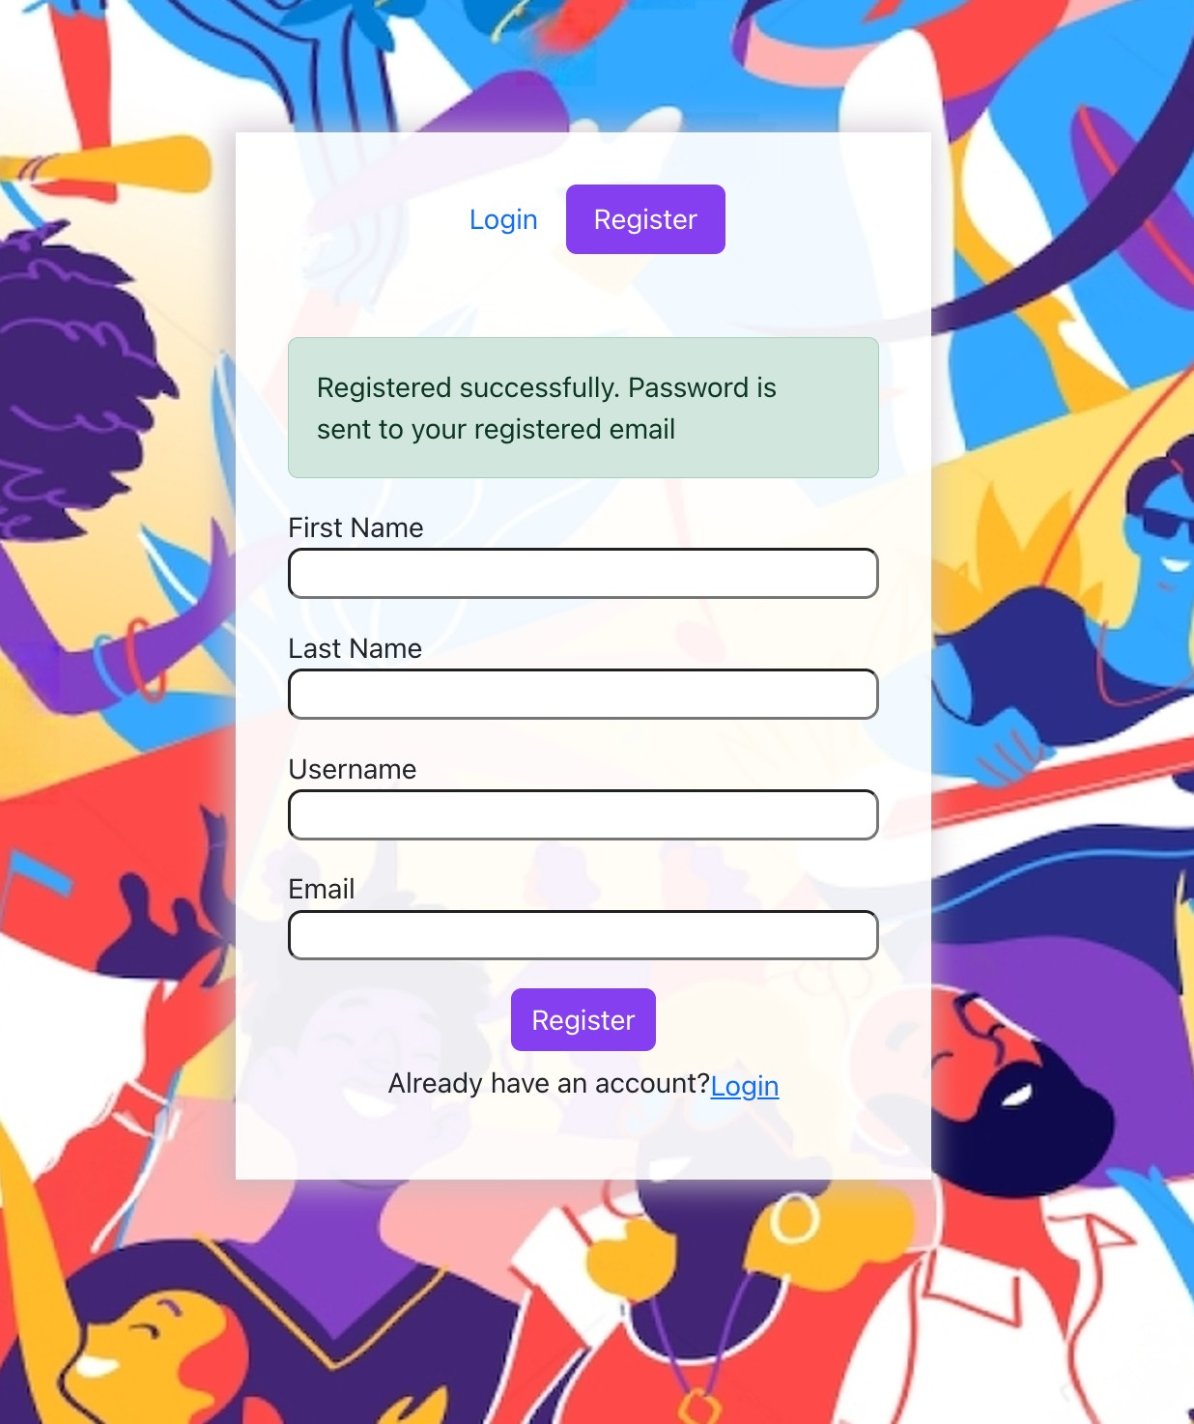

**TC002- Duplicate User Registration:**

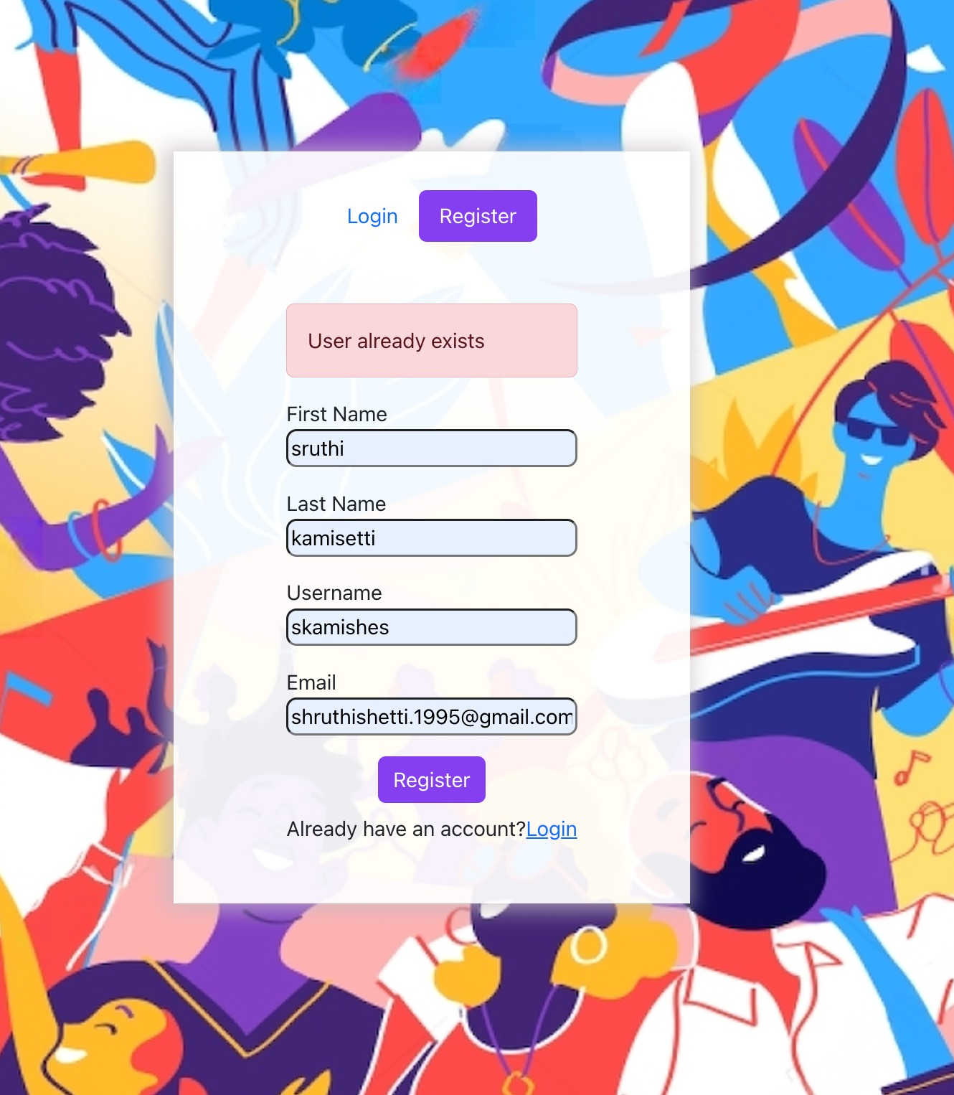

**TC002- Invalid Email:**

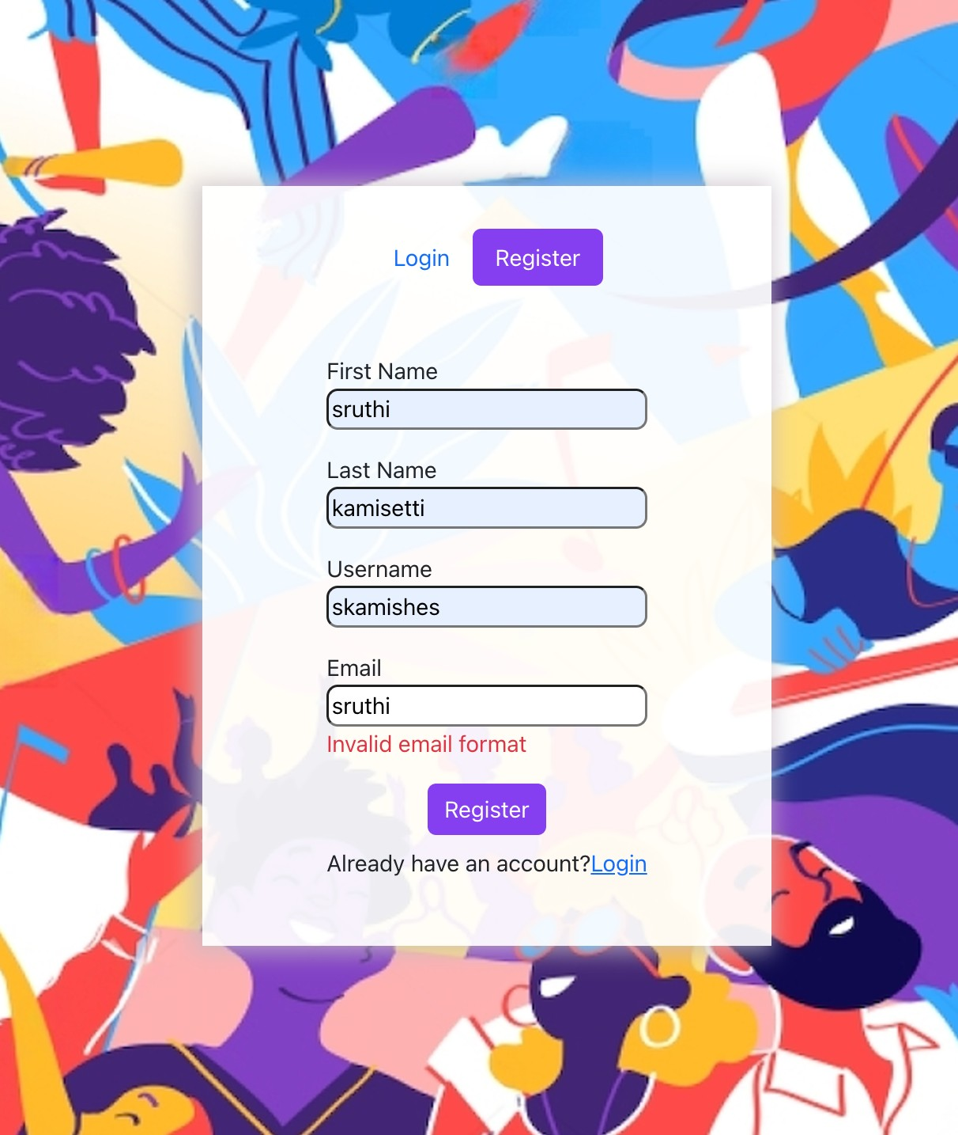

**TC003-Successful User login:**

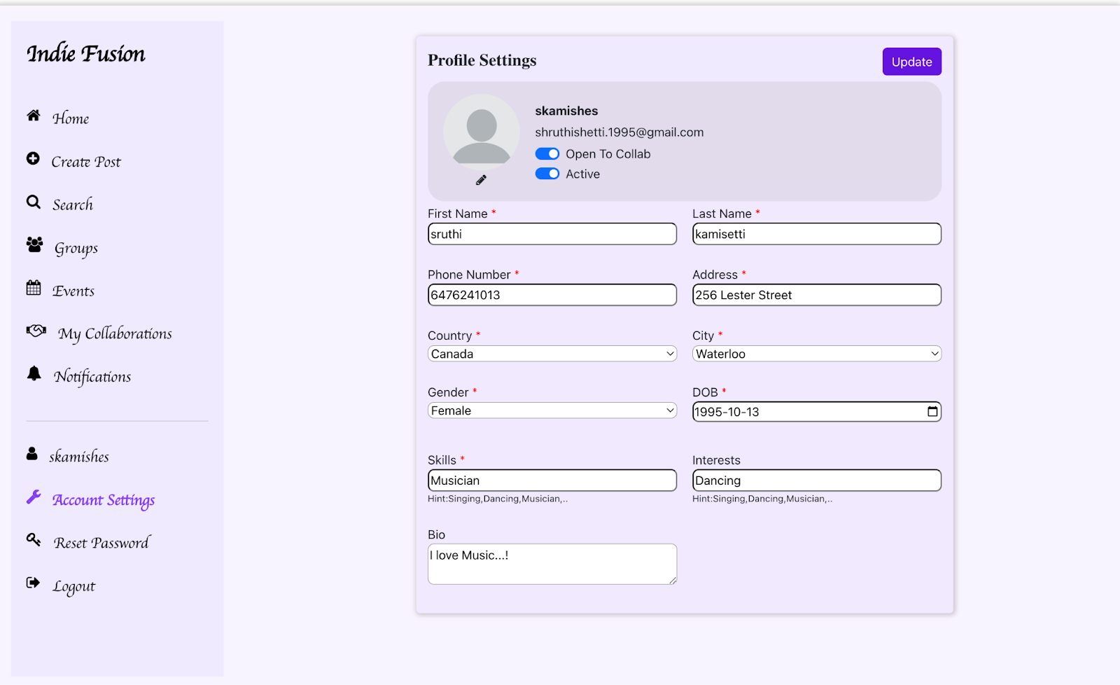

**TC004- Unsuccessful user login:**

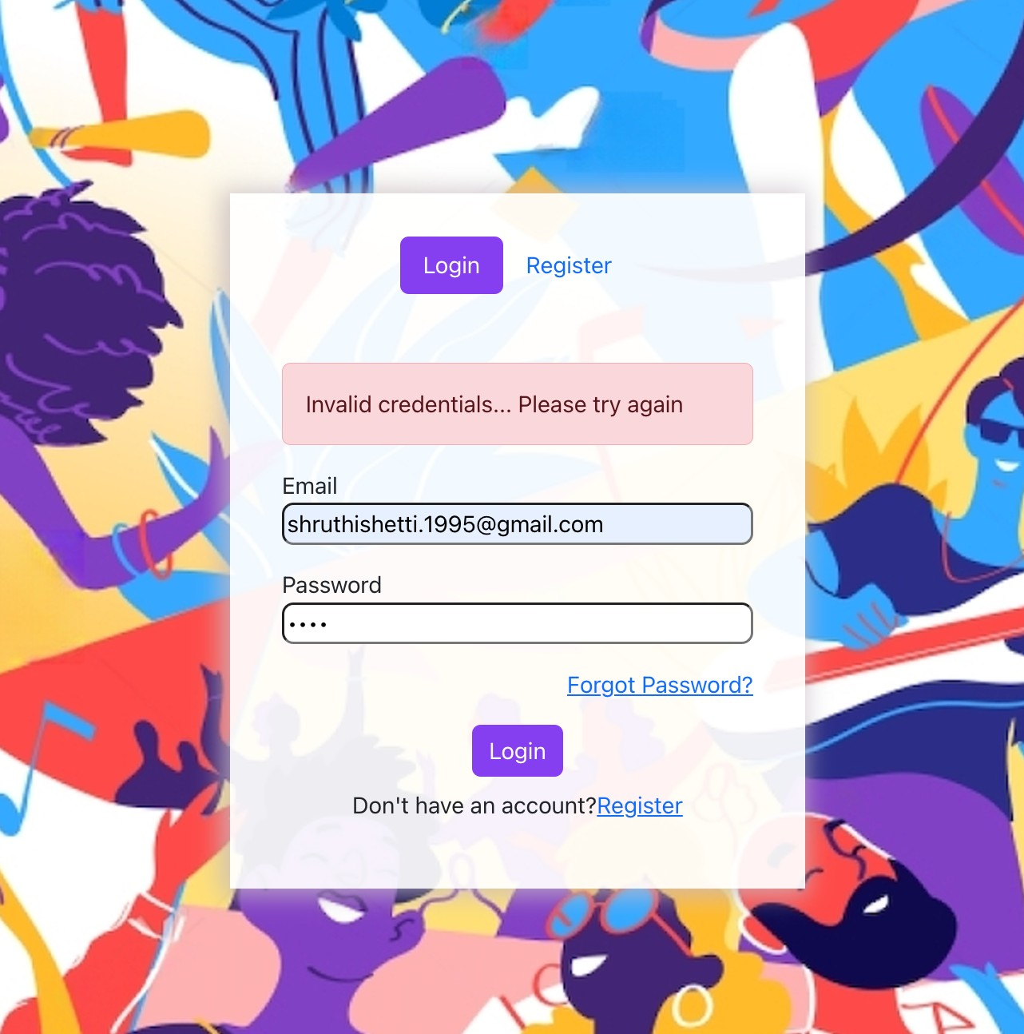

**TC005- Update user profile:**

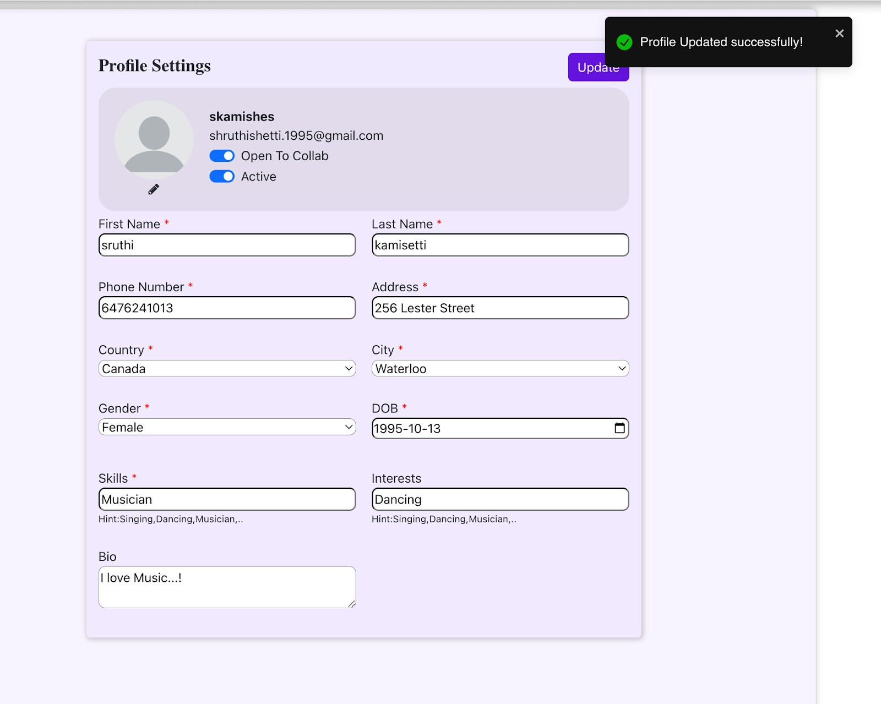

**TC006-Profile picture upload**

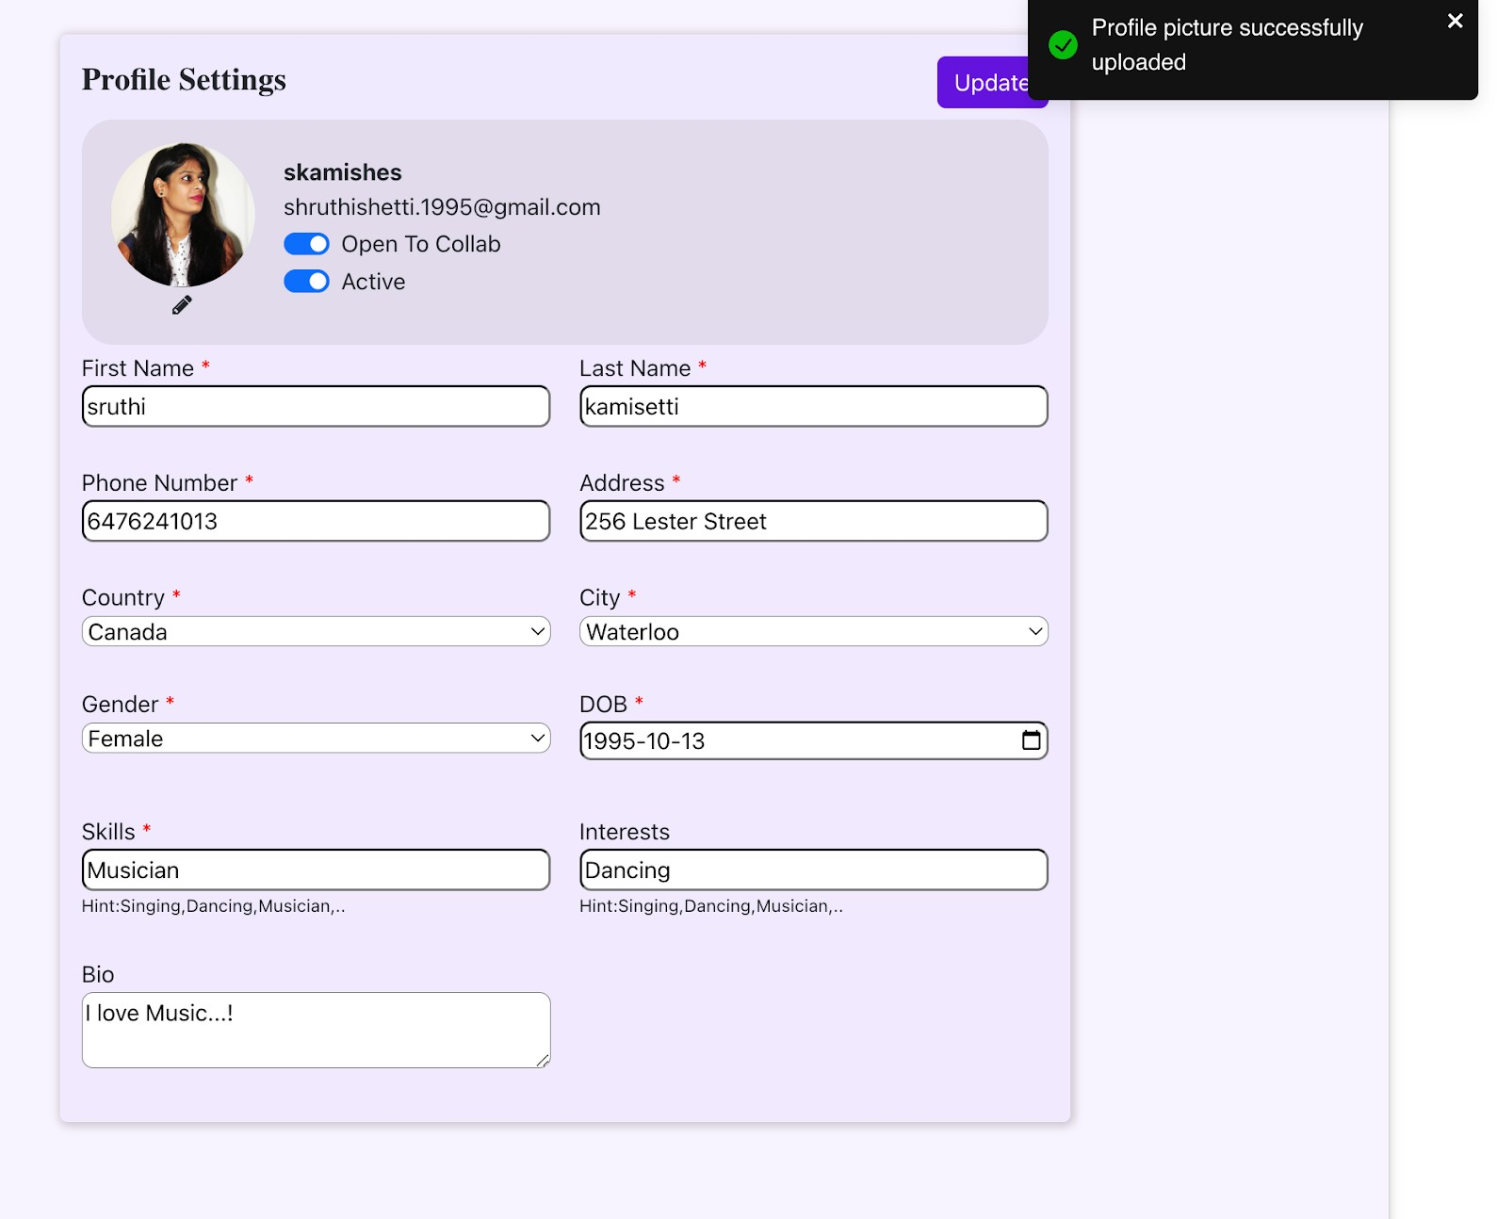

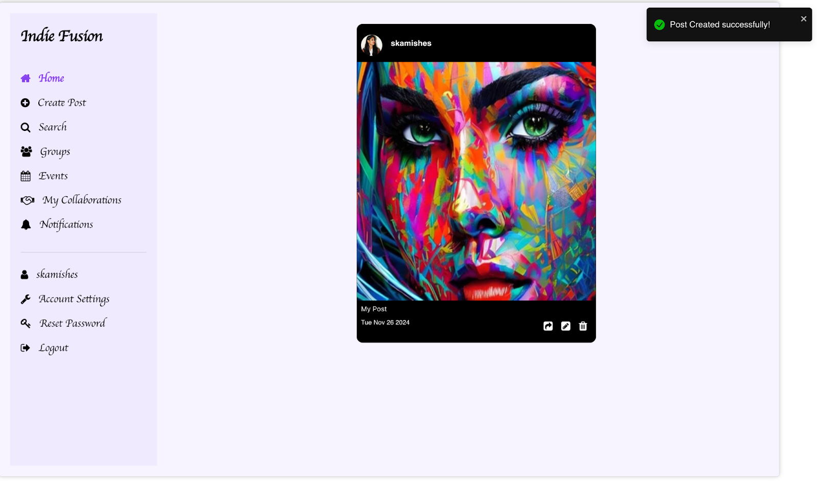**TC007- Create new post**:

**TC008 -Edit existing post**

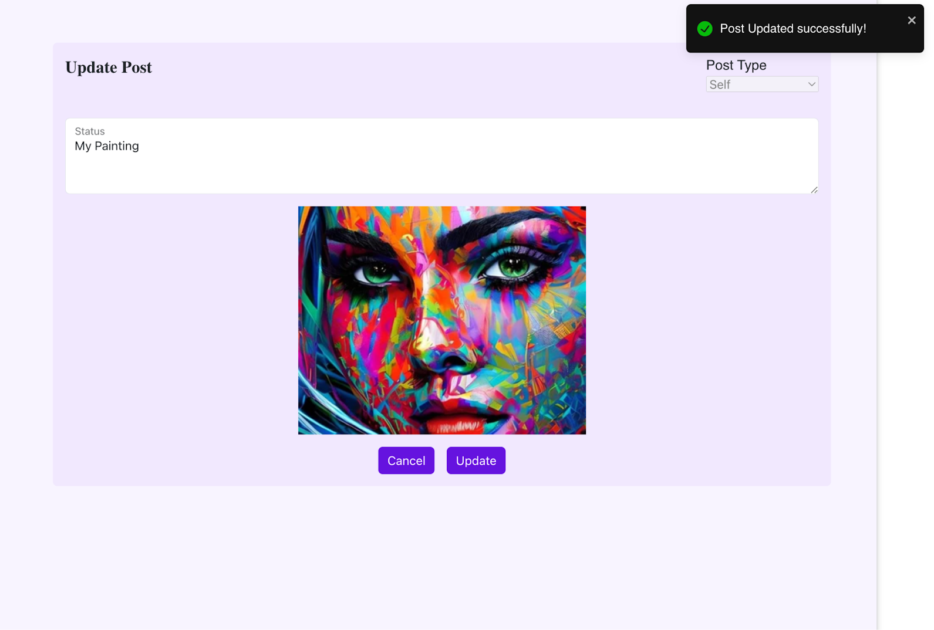

**TC009: Delete post**

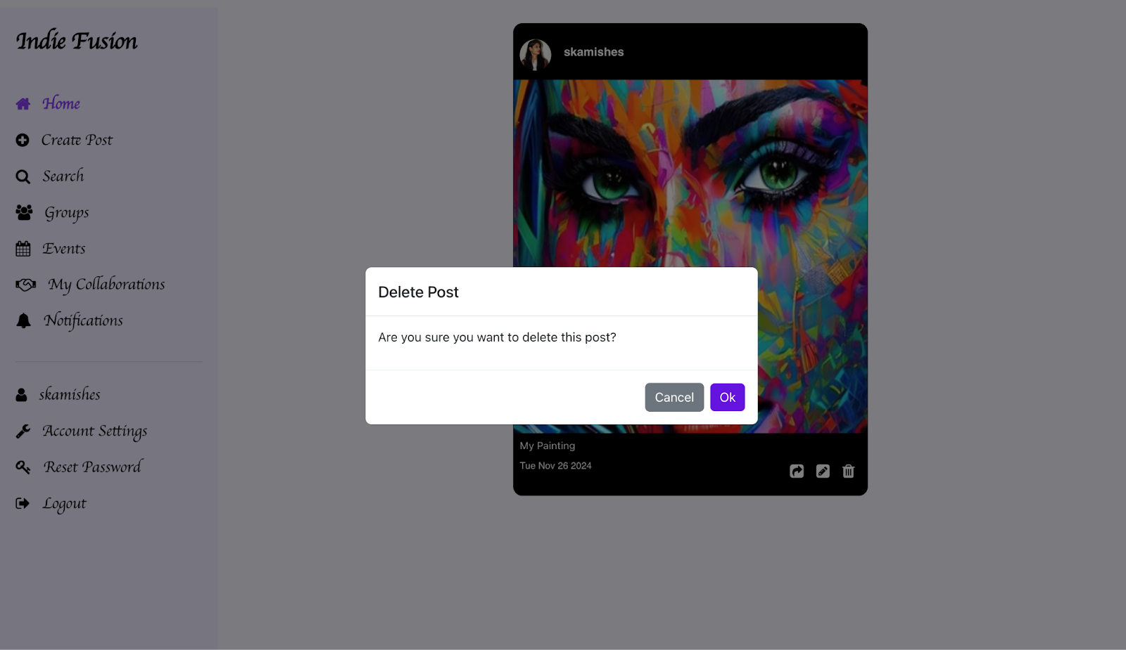

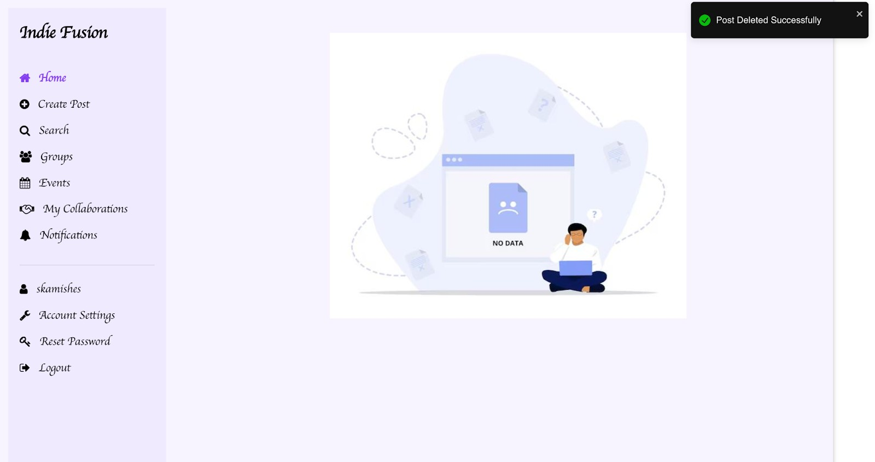

**TC010-Search for Artists:**

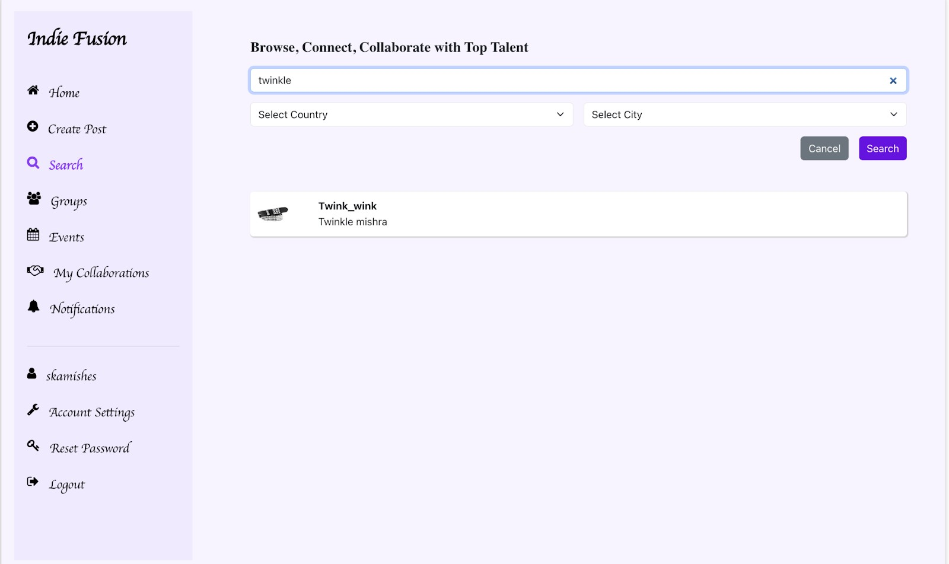

**TC011-Search with invalid query:**

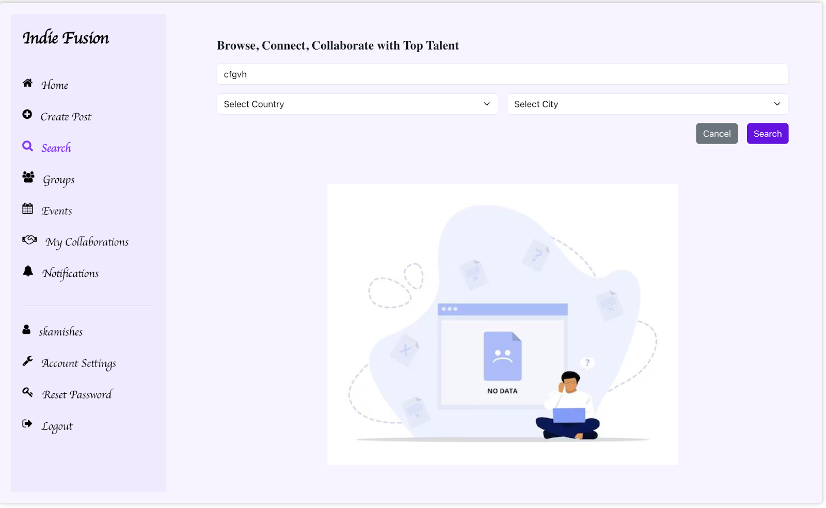

**TC012-Enable open to collab toggle:**

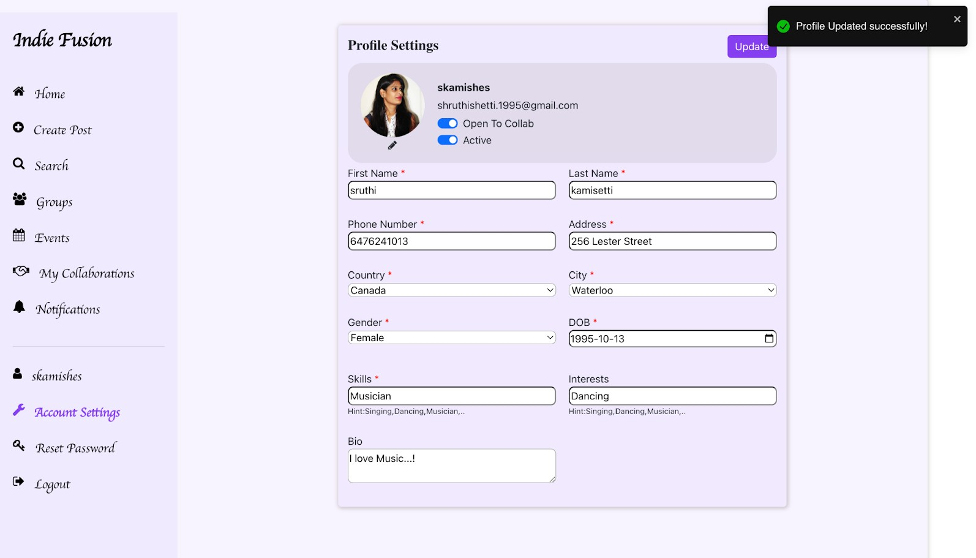

**TC013-Disable open to collab toggle:**

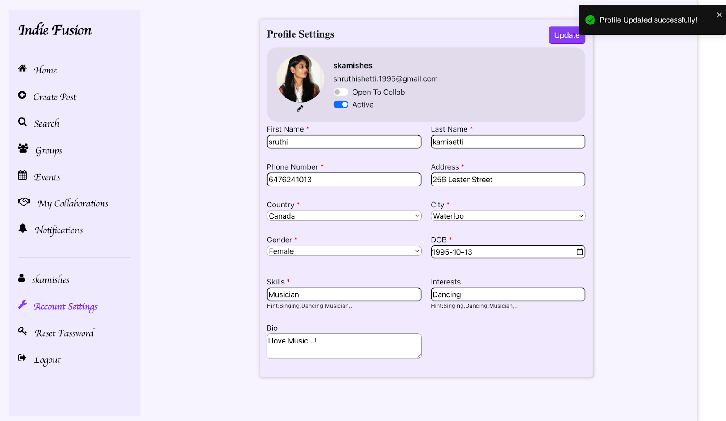

**TC014-Landing page UI:**

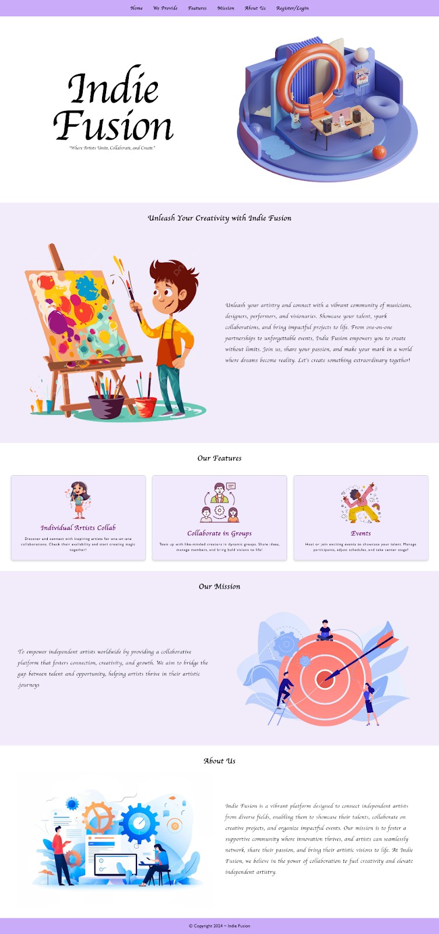

**TC016-Verify password hashing:**

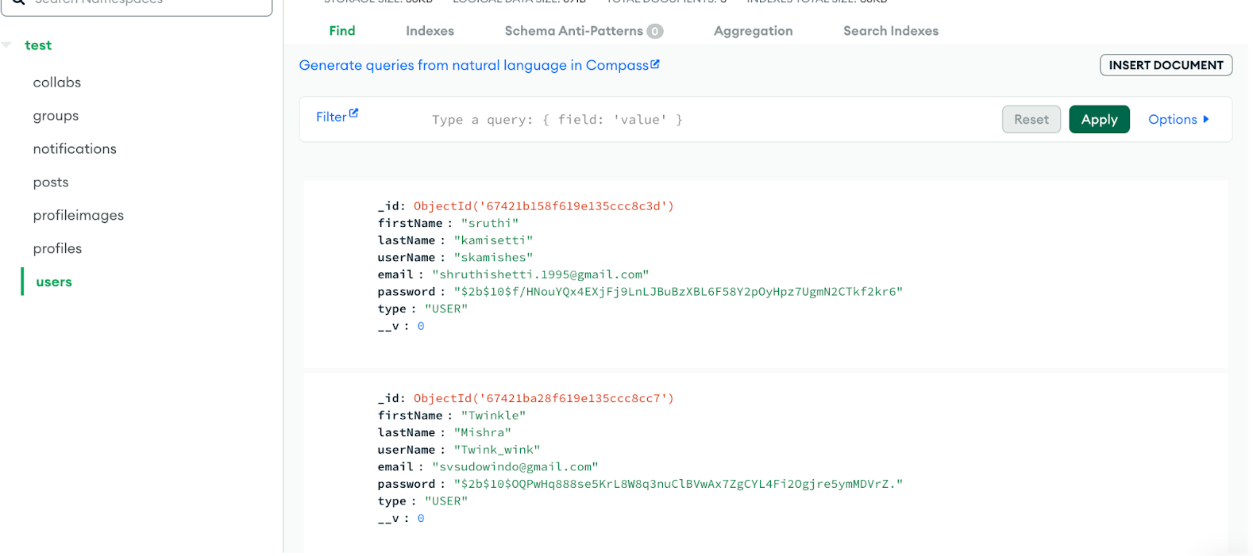

**Deployment Guide**

**About:** Indie Fusion is a vibrant platform designed to connect independent artists from diverse fields, enabling them to showcase their talents, collaborate on creative projects, and organize impactful events. Our mission is to foster a supportive community where innovation thrives, and artists can seamlessly network, share their passion, and bring their artistic visions to life. At Indie Fusion, we believe in the power of collaboration to fuel creativity and elevate independent artistry.

**Your App Name**: Indie Fusion

**Description**: Welcome to Indie Fusion, the ultimate platform for seamless indie artists collaboration. Our app offers features like Individual Artists collab, collaborate in groups, Exploring events.

**Quick Start**

Follow these instructions to set up and deploy the application.

#### Prerequisites

Ensure the following are installed on your system:

* + **Node.js**: Download from [nodejs.org](https://nodejs.org/).
  + **npm**: Comes with Node.js installation.
  + **React**: npm install -g create-react-app
  + **MongoDB Atlas**: Sign up for a free account at [MongoDB Atlas](https://www.mongodb.com/cloud/atlas).

#### Backend (Node.js and MongoDB) Setup

* + **Create a new folder for backend.**
  + **Clone the Repository**: git clone https://github.com/Sruthishetti951/indie-fusion-backend.git
  + cd indie-fusion-backend()
  + **Install Dependencies**: npm install
  + **Run the Server**: node server.js
  + The backend server will start at http://localhost:8080.

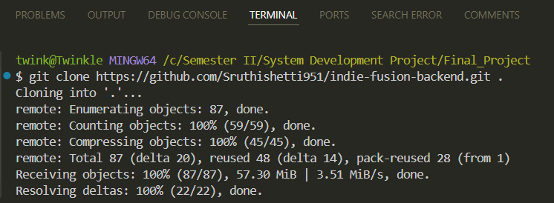

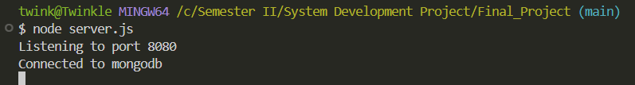

#### Frontend (React) Setup

* + **Create a new folder for frontend**
  + **Clone the Repository**: git clone https://github.com/Sruthishetti951/indie-fusion-ui.git
  + cd indie-fusion-ui()
  + **Install Dependencies**: npm install
  + **Configure API URL**: Update the API_URL in the React app configuration (e.g.,

src/appConfig.js to:

export const API_URL='http://localhost:8080'

* + **Run the Application**: npm run start
  + The React app will start at http://localhost:3000.
  + To use this app, register with your valid email address.

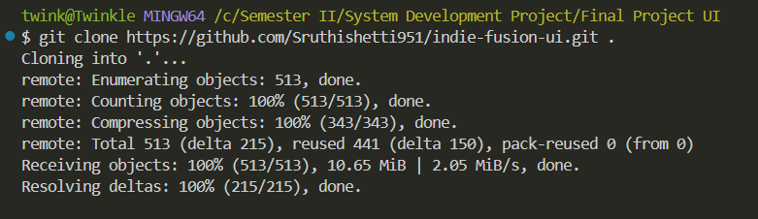

**Deployment Instructions**

#### Backend Deployment (Node.js) on Render

* + **Sign Up/Log In to Render:** Go to [Render](https://render.com/) and log in.
* **Create a New Web Service:**
  + Navigate to **Dashboard > New > Web Service**.
  + Connect to your backend repository.
* **Configure Settings:**
  + **Branch**: Choose the deployment branch (main)
* **Build Command**: npm install
* **Start Command**: node server.js
* **Deploy**: Render will automatically deploy the backend and provide a URL

https://indie-fusion-backend.onrender.com

#### Frontend Deployment (React) on Render

* **Create a Static Site**:
  + Navigate to **Dashboard > New > Static Site**.
  + Connect to your frontend repository.
* **Configure Settings**:
  + **Branch**: Choose the deployment branch (main)
* **Build Command**: npm install && npm run build
* **Publish Directory**: build
* **Update API URL:** In the React app, set the API_URL to your Render backend URL. export const API_URL='https://indie-fusion-backend.onrender.com'
* **Deploy**: Render will deploy the frontend and provide a URL

[https://indie-fusion-ui.onrender.com](https://indie-fusion-ui.onrender.com/)

**How to Create the Database**

Creating a database on MongoDB Atlas involves several steps, from setting up a MongoDB Atlas account to configuring your cluster and connecting your application. Here's a

step-by-step guide:

**MongoDB Atlas Setup**

1. **Create a Free Cluster**:
   * Log in to [MongoDB Atlas](https://www.mongodb.com/cloud/atlas).
   * Create a cluster in your preferred region.
2. **Whitelist IP Address**:
   * Go to **Network Access** > **Add IP Address**.
   * Add your current IP or allow access from all IPs (0.0.0.0/0) for development purposes.
3. **Create Database User**:
   * Go to **Database Access** > **Add New Database User**.
   * Set a username and password.
4. **Get Connection String**:
   * Go to **Clusters** > **Connect** > **Connect Your Application**.
5. **In the backend code add this connection string:** const mongoURI = 'mongodb+srv://Indie_Fusion:indiefusion123@[cluster0.lg87j.mongodb.net/?retryWrite](http://cluster0.lg87j.mongodb.net/?retryWrites=true&w=majority&appName=Cluster0) [s=true&w=majority&appName=Cluster0](http://cluster0.lg87j.mongodb.net/?retryWrites=true&w=majority&appName=Cluster0)'

Figure 1: 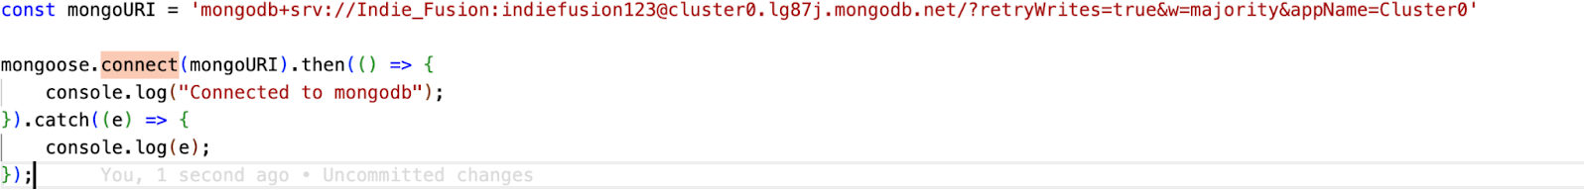

**Application Access**

* **Frontend URL:**

Visit https://indie-fusion-ui.onrender.com

* **Backend URL:**

Backend APIs are accessible at

[https://indie-fusion-backend.onrender.com](https://indie-fusion-backend.onrender.com/)

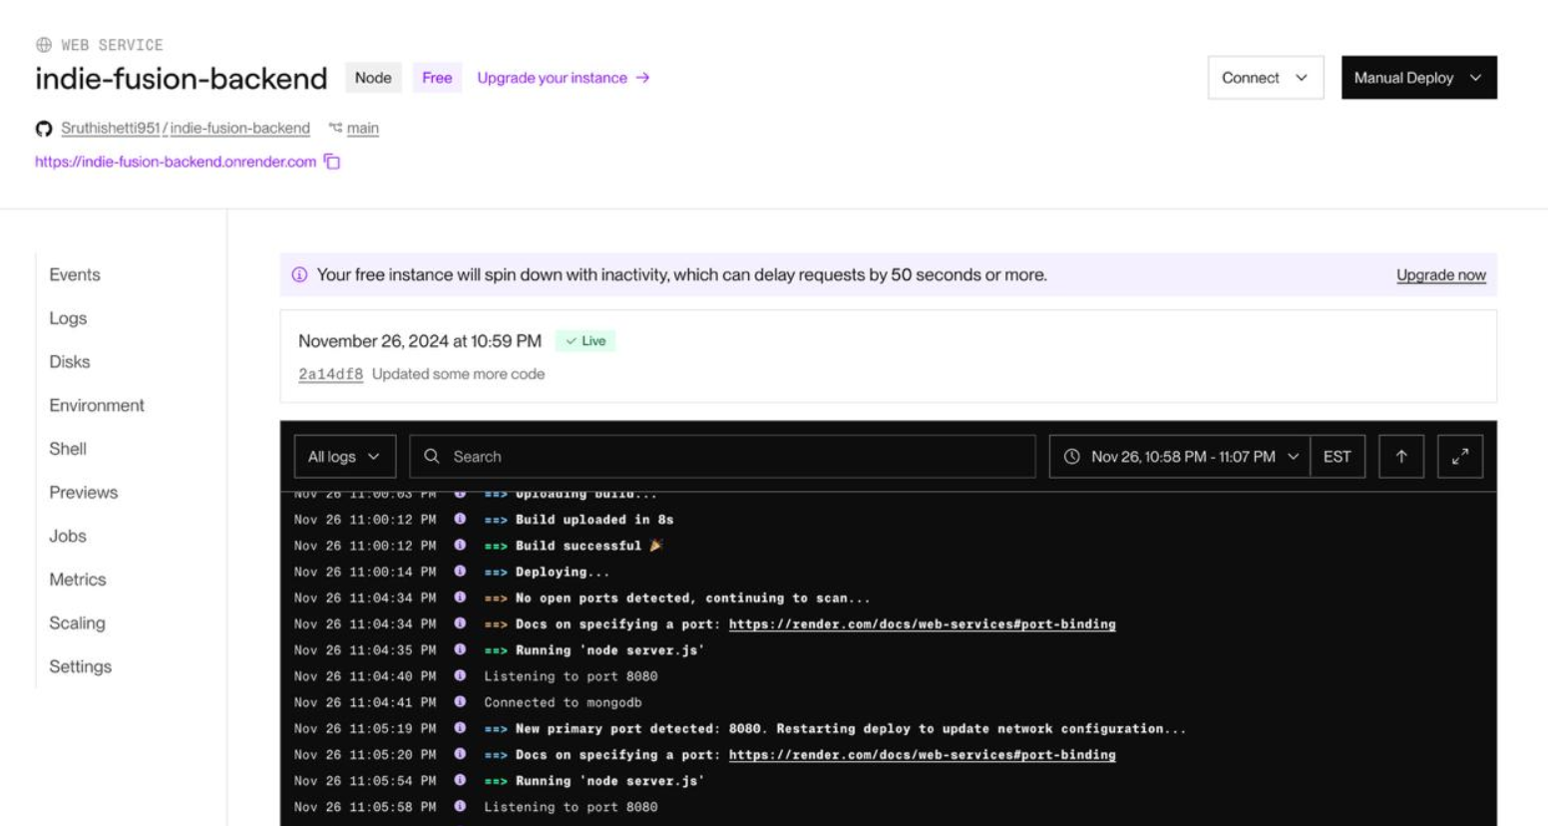

* **Note:** **During the first login/register or after a prolonged period of inactivity,**

**the website may take up to 50 seconds to 1 minute to get activated.**

**This is because the service is hosted on a free platform called Render,**

**which temporarily deactivates the application when not in use.**

**Mentor Waiver**

The undersigned permit Conestoga College Information Technology faculty to use the finished application and other deliverables for classroom demonstrations and the marketing of Conestoga College Information Technology programs. Conestoga College Information Technology faculty agree to use the source code only for marking purposes, and not to disclose or distribute the source code to any third party.

Signature: Sruthi Kamishetti ,Twinkle Mishra , Naina Jagiasi

Date: 02-12-2024

**Working Code Demonstration:**

Here is the link for our application demo:

[CAD_GROUP_01.MP4.mp4](https://stuconestogacon-my.sharepoint.com/:v:/g/personal/tmishra4858_conestogac_on_ca/EbtrTNQMKoBDmEgNT04XxUYBZb8v1YGJmrWd4PmdQnxtXQ?nav=eyJyZWZlcnJhbEluZm8iOnsicmVmZXJyYWxBcHAiOiJPbmVEcml2ZUZvckJ1c2luZXNzIiwicmVmZXJyYWxBcHBQbGF0Zm9ybSI6IldlYiIsInJlZmVycmFsTW9kZSI6InZpZXciLCJyZWZlcnJhbFZpZXciOiJNeUZpbGVzTGlua0NvcHkifX0&e=fSgJNW)